# **📘 dbt (Data Build Tool) – Complete Notes**

## **1️⃣ What is dbt?**

**dbt (Data Build Tool)** is an **open-source analytics engineering tool** used to **transform data inside the data warehouse** using **SQL** and **software engineering best practices**.

👉 dbt **does NOT extract or load data**.  
👉 dbt **only transforms data (T in ELT)**.

### **Simple Definition**

dbt helps data teams **write, test, document, and deploy SQL transformations** directly inside modern data warehouses.

### **Where dbt Works**

dbt runs transformations **inside the warehouse**, such as:

* Snowflake
* BigQuery
* Redshift
* Databricks (dbt + Spark SQL)
* Azure Synapse

## **2️⃣ Why Do We Need dbt?**

Before dbt, SQL transformations were:

❌ Scattered SQL scripts  
❌ Hard-coded logic  
❌ No version control  
❌ No testing  
❌ No documentation  
❌ Difficult debugging

### **Problems dbt Solves**

| **Problem** | **How dbt Fixes It** |
| --- | --- |
| No structured SQL | Modular SQL models |
| No lineage | Auto data lineage |
| No testing | Built-in data tests |
| No CI/CD | Git-based workflows |
| No documentation | Auto docs |
| Hard maintenance | Reusable models & macros |

## **3️⃣ ELT Architecture & dbt Role**

### **Traditional ETL**

Source → ETL Tool → Warehouse

### **Modern ELT (dbt fits here)**

Source → Warehouse → dbt (Transform)

### **Why ELT is Better**

✔ Scales with warehouse compute  
✔ Cheaper than ETL engines  
✔ Uses SQL (no custom code)  
✔ Faster development

## **4️⃣ Core Concepts of dbt**

### **1. Models**

* SQL select statements
* Each model = table or view in warehouse

SELECT

order_id,

customer_id,

order_date,

total_amount

FROM {{ ref('raw_orders') }}

### **2. Materializations**

Defines **how data is stored**:

* view
* table
* incremental
* ephemeral

materialized: incremental

### **3. Ref Function (Dependency Management)**

SELECT * FROM {{ ref('customers') }}

✔ Manages execution order  
✔ Enables lineage  
✔ Prevents broken dependencies

### **4. Tests**

dbt supports **data quality testing**:

#### **Generic Tests**

* not_null
* unique
* accepted_values
* relationships

tests:

- not_null

- unique

#### **Custom Tests**

Write SQL-based tests for business rules.

### **5. Documentation**

dbt automatically generates:

* Column descriptions
* Table definitions
* Lineage graphs

dbt docs generate

dbt docs serve

### **6. Macros (Reusable SQL Logic)**

Macros = SQL functions using **Jinja**.

{% macro get_current_date() %}

current_date

{% endmacro %}

✔ Avoid code duplication  
✔ Standardize logic

### **7. Snapshots (Slowly Changing Dimensions)**

Tracks **historical changes** in dimension tables.

Used for:

* SCD Type 2
* Audit history
* Change tracking

## **5️⃣ Why We Use dbt in Real Projects**

### **Business Use Cases**

* Transform raw data into analytics-ready tables
* Build star schemas (fact & dimension)
* Create KPIs & metrics
* Ensure data quality
* Enable self-service analytics

### **dbt in Analytics Engineering**

dbt introduced a new role:

**Analytics Engineer**

Responsibilities:

* Own transformation layer
* Ensure data quality
* Define business logic
* Bridge data engineers & analysts

## **6️⃣ Why ONLY dbt (Even When Other Tools Exist?)**

### **Popular Alternatives**

| **Tool** | **Limitation** |
| --- | --- |
| Informatica | Expensive, heavy UI |
| Talend | Complex setup |
| Airflow | Orchestration, not transformation |
| SSIS | Legacy, not cloud-native |
| Spark Jobs | Overkill for SQL transformations |

### **Why dbt is Preferred 🚀**

### **1️⃣ SQL First (Huge Advantage)**

✔ Most analysts already know SQL  
✔ No Java / Scala / Python needed

### **2️⃣ Version Control Friendly**

✔ Git-based  
✔ PR reviews  
✔ Rollbacks  
✔ CI/CD pipelines

### **3️⃣ Built-in Testing**

✔ Data quality checks at model level  
✔ Prevents bad data reaching dashboards

### **4️⃣ Auto Lineage & Documentation**

✔ End-to-end dependency graph  
✔ No manual docs needed

### **5️⃣ Warehouse-Native**

✔ Pushes compute to Snowflake/Databricks  
✔ No data movement  
✔ Highly scalable

### **6️⃣ Incremental Models**

✔ Processes only new/changed data  
✔ Saves cost & time

### **7️⃣ Strong Community & Ecosystem**

✔ dbt Hub packages  
✔ Prebuilt macros  
✔ Open source innovation

## **7️⃣ dbt vs Other Tools (Interview Table)**

| **Feature** | **dbt** | **ETL Tools** |
| --- | --- | --- |
| Transformation Layer | ✅ | ❌ |
| SQL Based | ✅ | ❌ |
| Version Control | ✅ | ❌ |
| Data Testing | ✅ | ❌ |
| Documentation | ✅ | ❌ |
| Cost | Low | High |
| Cloud Native | ✅ | Partial |

## **8️⃣ dbt with Databricks (Important)**

Since you work with **Databricks**, dbt integrates as:

✔ dbt + Spark SQL  
✔ Transform Delta tables  
✔ Build gold analytics layer  
✔ Works with Unity Catalog

Typical flow:

Bronze → Silver → Gold

↑

dbt

## **9️⃣ When NOT to Use dbt?**

dbt is **not suitable** when:

* Heavy ML pipelines
* Real-time streaming
* Complex procedural logic
* Data ingestion required

👉 dbt = **Transformation tool only**

## **🔟 One-Line Interview Answers**

**What is dbt?**

dbt is a SQL-based transformation tool that enables analytics engineering using ELT principles.

**Why dbt?**

It brings software engineering best practices to SQL transformations.

**Why dbt over ETL tools?**

dbt is warehouse-native, cost-effective, version-controlled, and analyst-friendly.

## **📌 Final Summary**

✔ dbt = Transform layer of modern data stack  
✔ SQL + Git + Testing + Documentation  
✔ Lightweight but powerful  
✔ Industry standard for analytics engineering

# **⭐ Main Features of dbt (Data Build Tool)**

dbt’s core strength comes from **four pillars**:

1️⃣ Develop  
2️⃣ Test  
3️⃣ Document  
4️⃣ Version Control & CI/CD

## **1️⃣ DEVELOP in dbt**

### **What “Develop” Means in dbt**

Developing in dbt means:

Writing **modular, reusable, and maintainable SQL transformations** using software engineering principles.

### **Key Development Features**

#### **1. SQL-Based Models**

* Each dbt model is a **SELECT query**
* dbt converts it into a **table/view/incremental table**

-- models/fact_sales.sql

SELECT

order_id,

customer_id,

order_date,

total_amount

FROM {{ ref('stg_orders') }}

✔ Easy to read  
✔ Easy to debug  
✔ No complex frameworks

#### **2. Modular Development using ref()**

SELECT * FROM {{ ref('dim_customers') }}

Benefits:

* Manages dependencies automatically
* Builds correct execution order
* Enables lineage tracking

#### **3. Materializations**

Control how data is stored:

| **Materialization** | **Use Case** |
| --- | --- |
| view | Lightweight transformations |
| table | Heavy aggregations |
| incremental | Large tables |
| ephemeral | Reusable subqueries |

materialized: incremental

#### **4. Macros (Reusable SQL)**

Macros allow **SQL reuse using Jinja**.

{% macro get_year(col_name) %}

year({{ col_name }})

{% endmacro %}

✔ Reduces code duplication  
✔ Standardizes logic

#### **5. Environment-Based Development**

* Dev
* QA
* Prod

dbt run --target dev

## **2️⃣ TEST in dbt**

### **Why Testing is Important**

Without testing:  
❌ Bad data reaches dashboards  
❌ Business loses trust  
❌ Errors go unnoticed

dbt provides **built-in data quality testing**.

### **Types of dbt Tests**

#### **1. Generic Tests (Built-in)**

Applied using YAML.

| **Test** | **Purpose** |
| --- | --- |
| not_null | No null values |
| unique | No duplicates |
| accepted_values | Allowed values |
| relationships | Foreign key check |

columns:

- name: order_id

tests:

- not_null

- unique

#### **2. Custom Tests**

SQL queries that return **failed records**.

SELECT *

FROM {{ ref('fact_sales') }}

WHERE total_amount < 0

✔ Enforces business rules  
✔ Flexible

### **When Tests Run**

* During development
* In CI pipelines
* Before production deployment

dbt test

## **3️⃣ DOCUMENT in dbt**

### **What dbt Documentation Does**

dbt automatically generates:

* Table descriptions
* Column-level metadata
* Data lineage graph

### **How Documentation is Written**

#### **Schema YAML**

models:

- name: fact_sales

description: "Sales fact table"

columns:

- name: order_id

description: "Unique order identifier"

### **Generate & View Docs**

dbt docs generate

dbt docs serve

### **Benefits of dbt Docs**

✔ Self-service analytics  
✔ Business-friendly explanations  
✔ Always in sync with code  
✔ Shows upstream & downstream dependencies

## **4️⃣ VERSION CONTROL & CI/CD in dbt**

### **Version Control (Git Integration)**

dbt projects are **fully Git-based**.

✔ Track changes  
✔ Collaborate in teams  
✔ Rollback easily  
✔ Code reviews via PRs

Typical Git Flow:

Feature Branch → Pull Request → Main Branch

### **CI/CD in dbt (How It Works)**

#### **CI (Continuous Integration)**

Runs automatically when code is pushed.

Common CI checks:

* dbt compile
* dbt run (limited models)
* dbt test

dbt build --select state:modified+

#### **CD (Continuous Deployment)**

* Deploy to production after PR approval
* Runs full dbt models
* Executes tests before publishing data

dbt run --target prod

dbt test --target prod

### **dbt + CI/CD Tools**

Common integrations:

* GitHub Actions
* GitLab CI
* Azure DevOps
* dbt Cloud

### **dbt Cloud Advantages**

✔ Built-in CI  
✔ Job scheduling  
✔ Environment separation  
✔ Monitoring & alerts

## **5️⃣ End-to-End dbt Feature Flow**

Develop → Test → Document → Version Control → CI/CD → Production

## **6️⃣ Interview-Friendly One-Liners**

**Develop:**

dbt allows modular SQL development using ref, macros, and materializations.

**Test:**

dbt provides built-in data quality tests and custom SQL tests.

**Document:**

dbt auto-generates documentation and lineage directly from code.

**Version Control & CI/CD:**

dbt integrates seamlessly with Git and CI/CD pipelines to ensure safe deployments.

## **7️⃣ Quick Comparison Summary**

| **Feature** | **dbt** |
| --- | --- |
| SQL-first | ✅ |
| Testing | ✅ |
| Documentation | ✅ |
| Lineage | ✅ |
| Git Integration | ✅ |
| CI/CD Ready | ✅ |

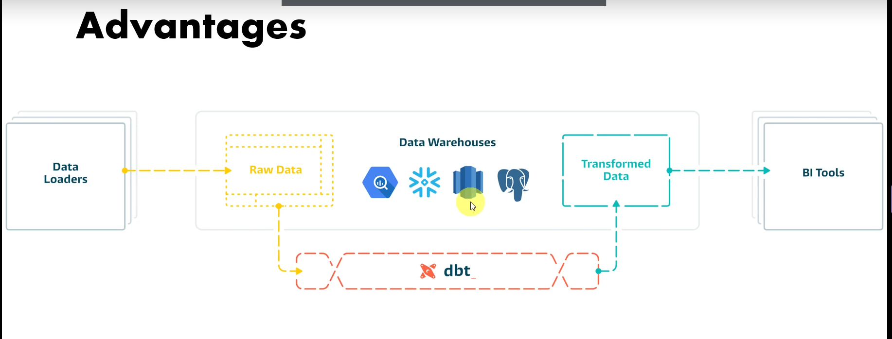

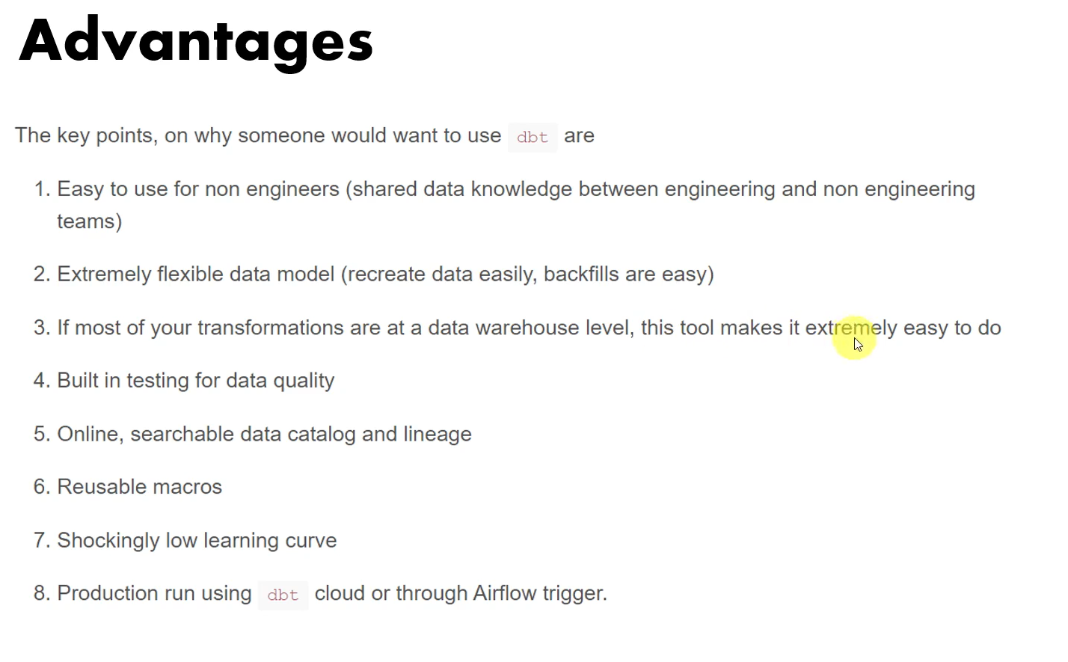

# **🚀 dbt with Snowflake – Step-by-Step Setup (Best Notes)**

## **📌 Architecture Overview (Before Setup)**



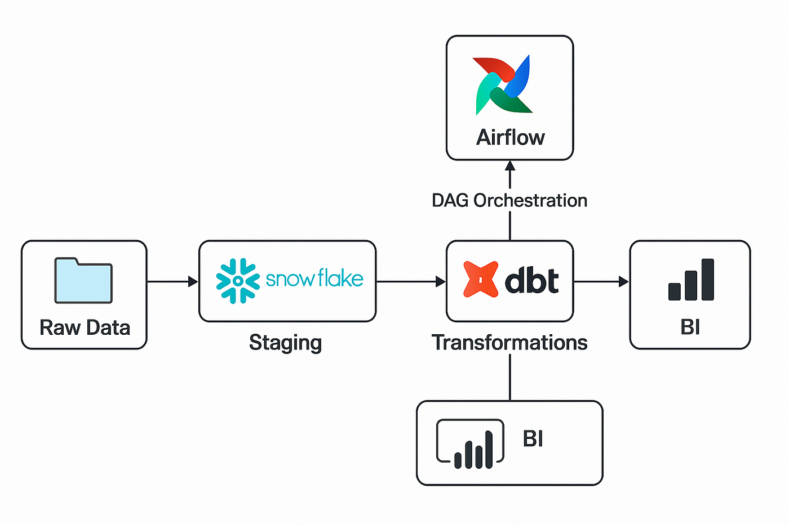

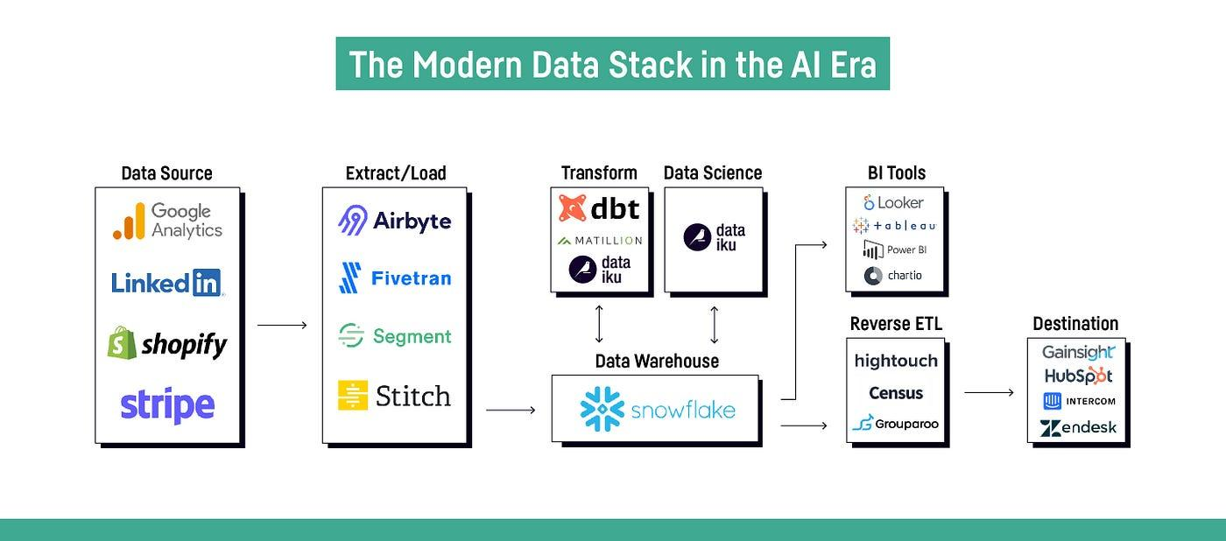

### **How dbt Works with Snowflake**

Source Systems → Snowflake (RAW) → dbt (Transform) → Analytics Tables

✔ Snowflake stores data  
✔ dbt runs SQL inside Snowflake  
✔ No data movement  
✔ ELT architecture

## **1️⃣ Prerequisites**

Before starting, ensure you have:

### **Snowflake**

* Account
* Warehouse
* Database
* Schema
* User with proper role

### **Local Machine**

* Python 3.8+
* pip installed
* Git (recommended)

## **2️⃣ Snowflake Setup (One-Time)**

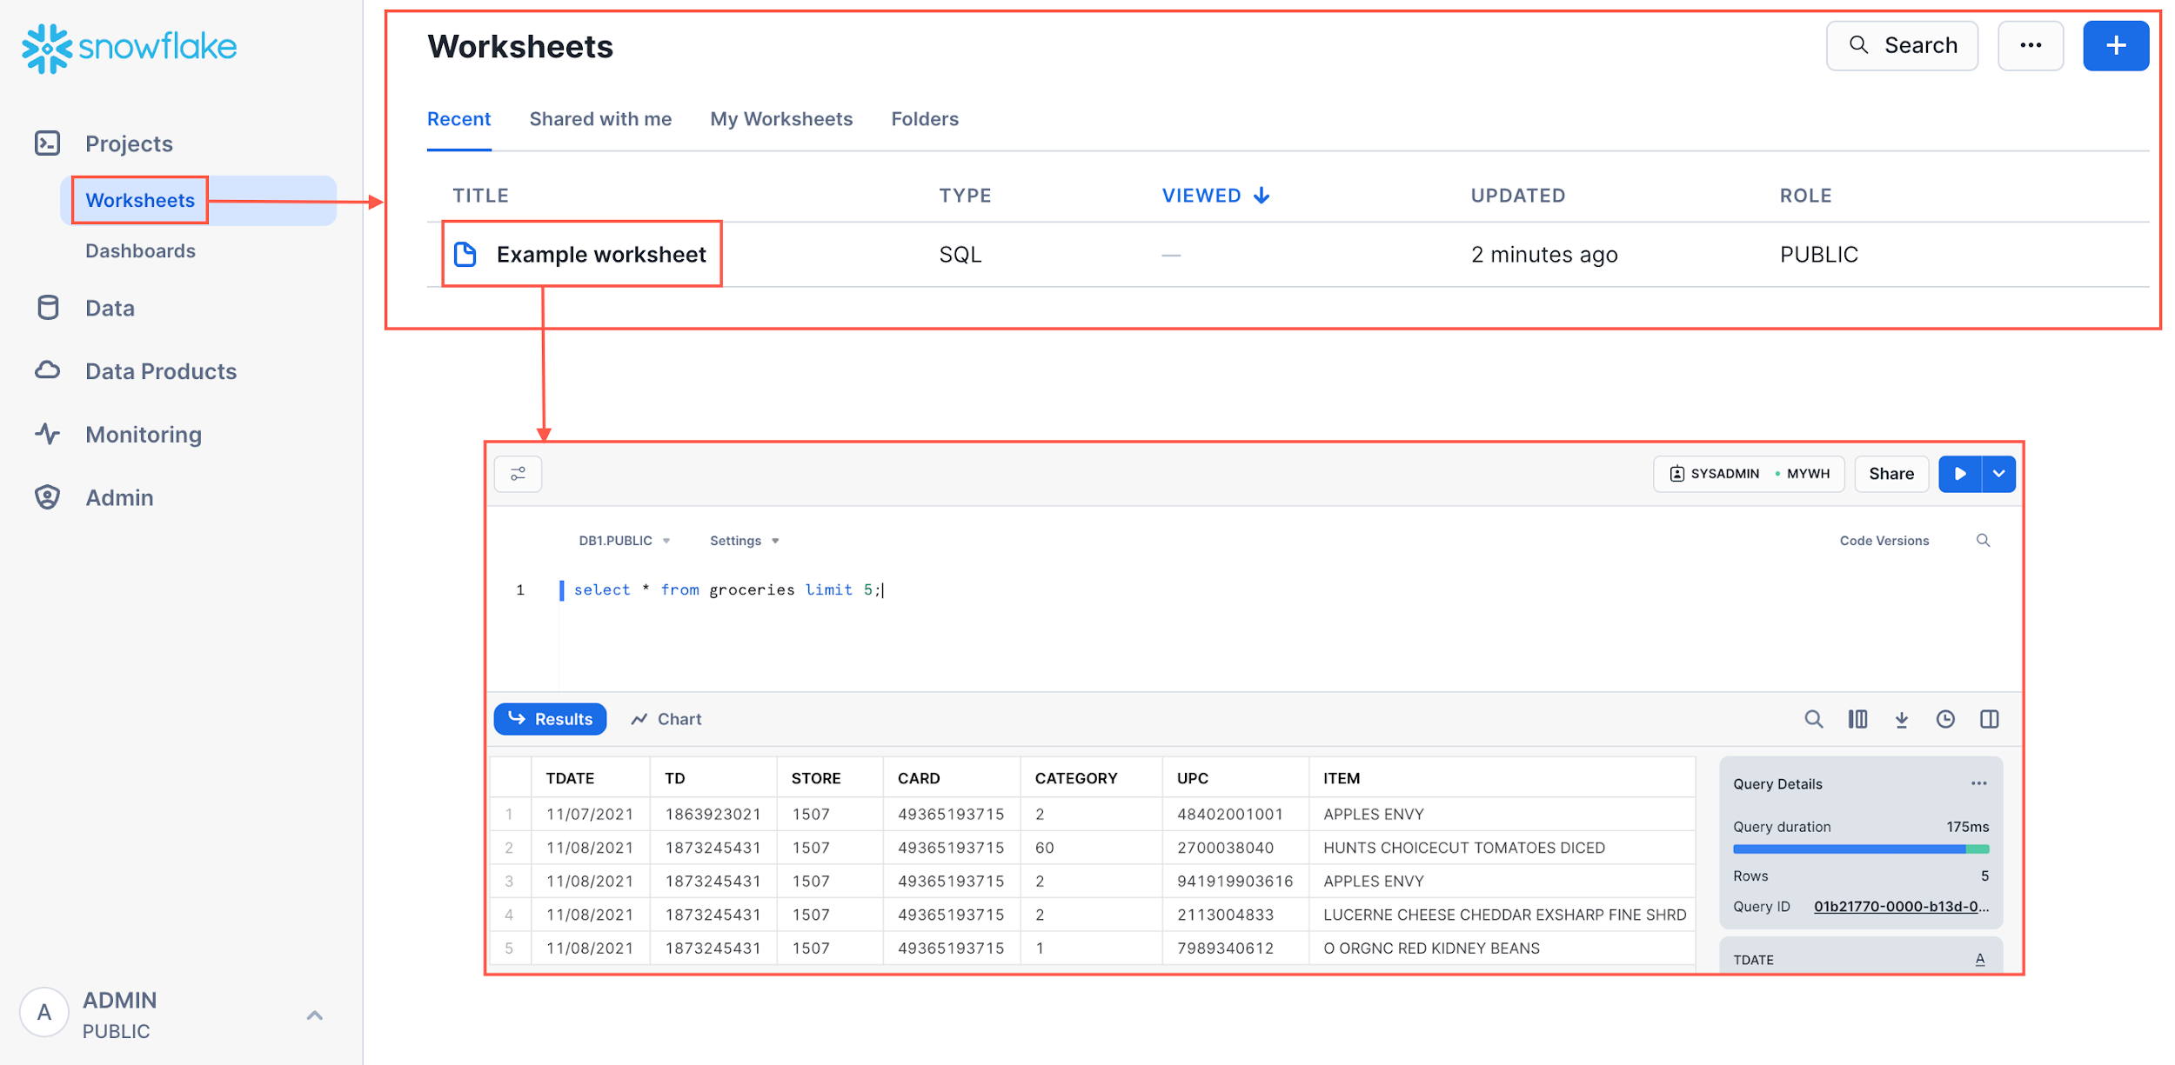



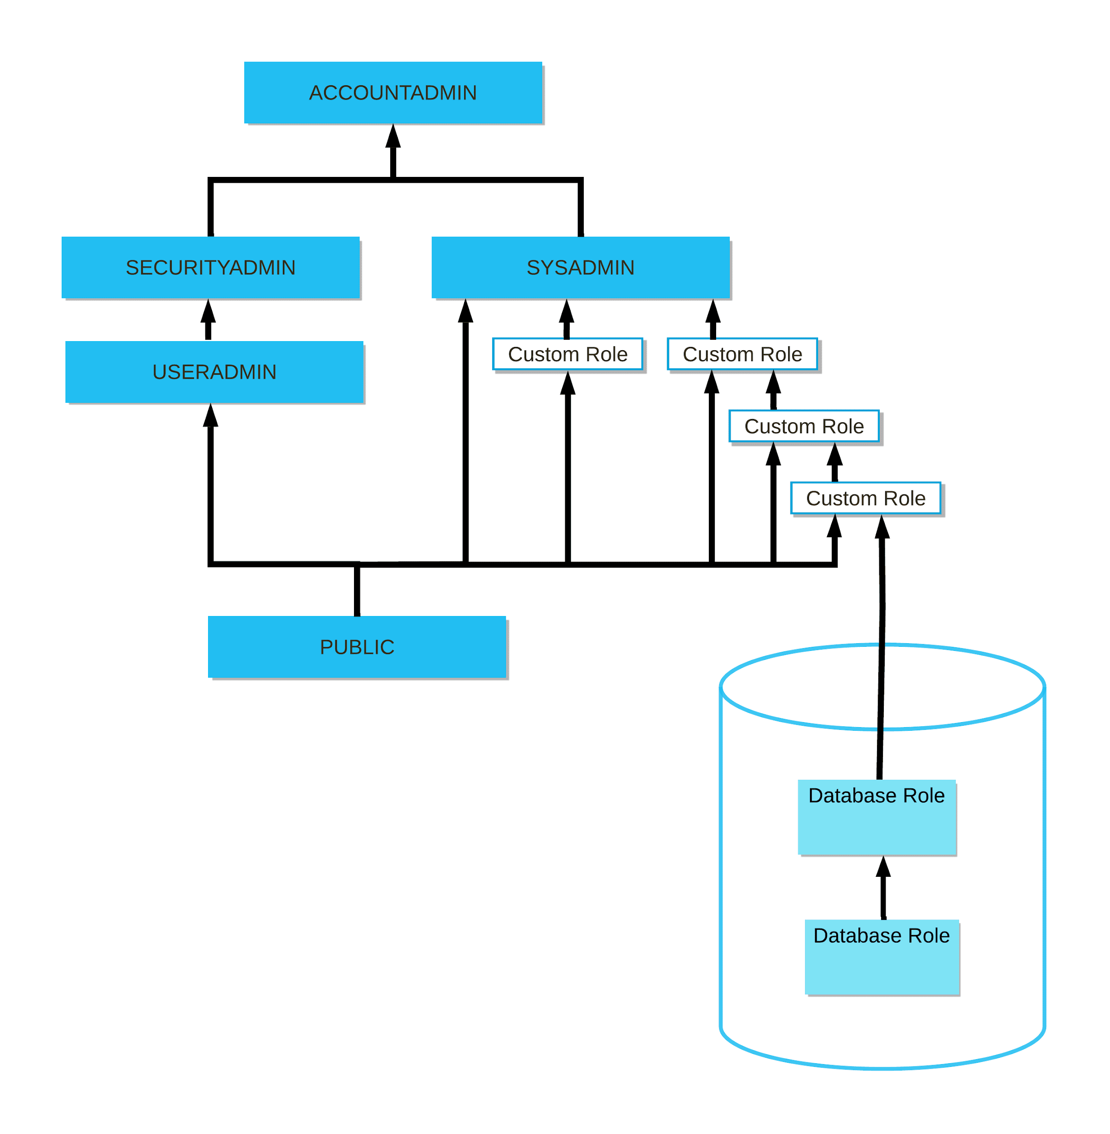

### **Create Warehouse**

CREATE WAREHOUSE dbt_wh

WITH WAREHOUSE_SIZE = 'XSMALL'

AUTO_SUSPEND = 60;

### **Create Database & Schema**

CREATE DATABASE analytics_db;

CREATE SCHEMA analytics_db.dbt_schema;

### **Create dbt User**

CREATE USER dbt_user

PASSWORD = 'StrongPassword'

DEFAULT_ROLE = 'SYSADMIN';

### **Grant Permissions**

GRANT USAGE ON WAREHOUSE dbt_wh TO USER dbt_user;

GRANT ALL ON DATABASE analytics_db TO USER dbt_user;

📌 **Why this is important:**dbt must be able to **create tables/views** in Snowflake.

## **3️⃣ Install dbt for Snowflake**

### **Step 1: Create Virtual Environment (Recommended)**

python -m venv dbt_env

source dbt_env/bin/activate # Linux/Mac

dbt_env\Scripts\activate # Windows

### **Step 2: Install dbt-Snowflake Adapter**

pip install dbt-snowflake

### **Verify Installation**

dbt --version

✔ Confirms dbt is installed  
✔ Shows Snowflake adapter

## **4️⃣ Initialize dbt Project**

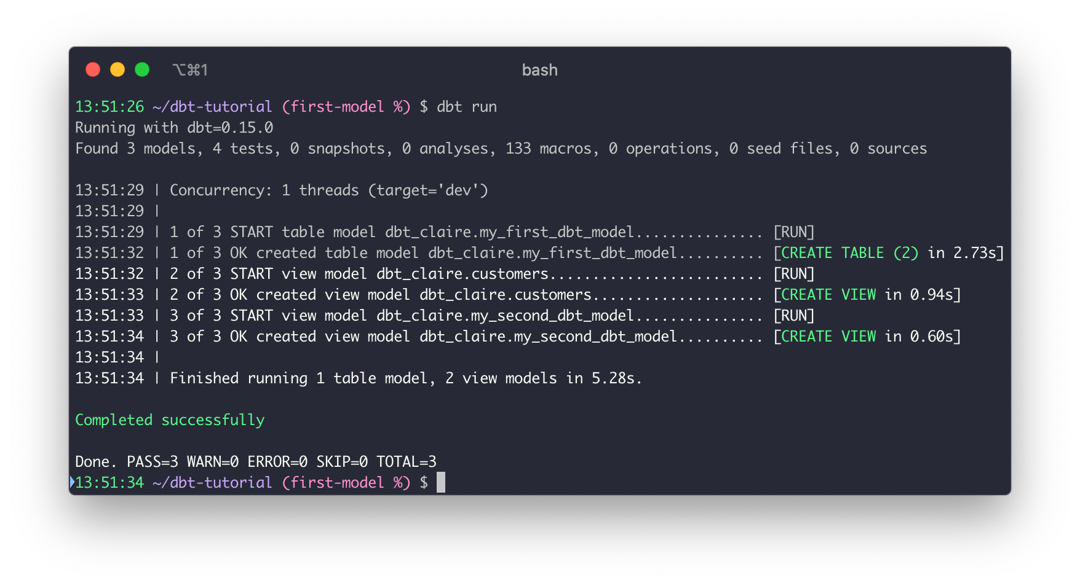

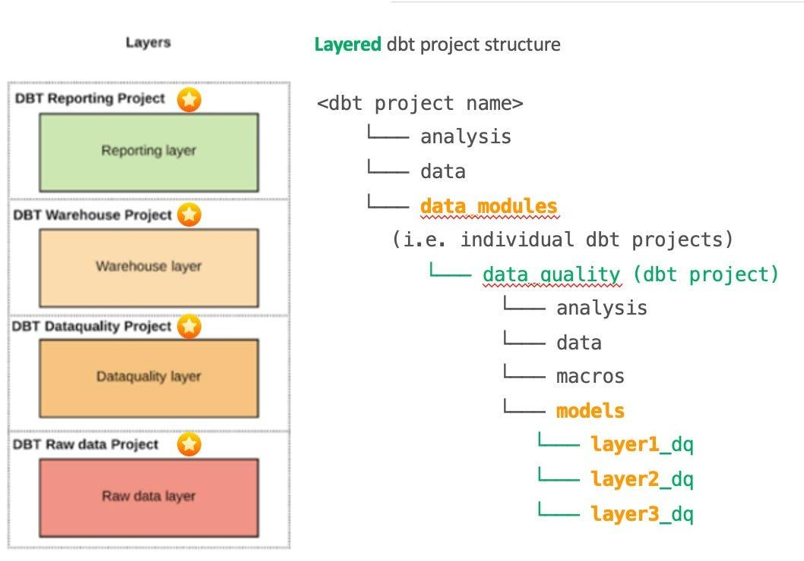

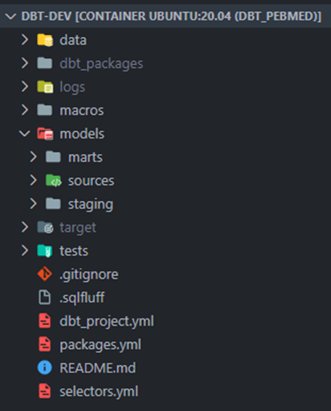

dbt init my_dbt_project

cd my_dbt_project

During setup, dbt will ask:

* Database: analytics_db
* Schema: dbt_schema
* Warehouse: dbt_wh
* Role: SYSADMIN

## **5️⃣ Configure Snowflake Connection (profiles.yml)**

📍 Location:

~/.dbt/profiles.yml

### **Sample Snowflake Profile**

my_dbt_project:

target: dev

outputs:

dev:

type: snowflake

account: abc12345.us-east-1

user: dbt_user

password: StrongPassword

role: SYSADMIN

database: analytics_db

warehouse: dbt_wh

schema: dbt_schema

threads: 4

📌 **Key Parameters Explained**

| **Parameter** | **Meaning** |
| --- | --- |
| account | Snowflake account identifier |
| warehouse | Compute engine |
| database | Target database |
| schema | Where dbt creates tables |
| threads | Parallel execution |

## **6️⃣ Test the Connection**

dbt debug

✔ Checks Snowflake connectivity  
✔ Validates credentials  
✔ Confirms warehouse access

✅ **Expected Result:**All checks passed!

## **7️⃣ Create First dbt Model**

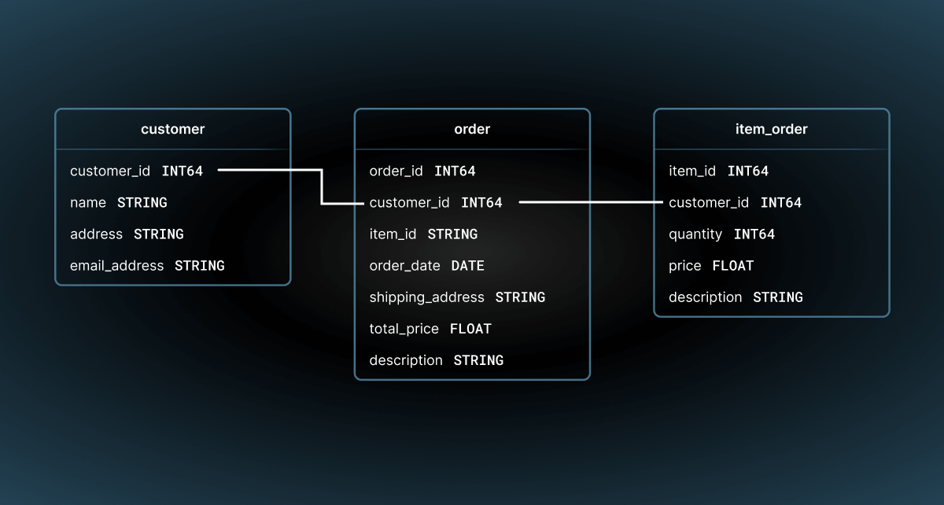

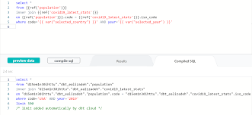

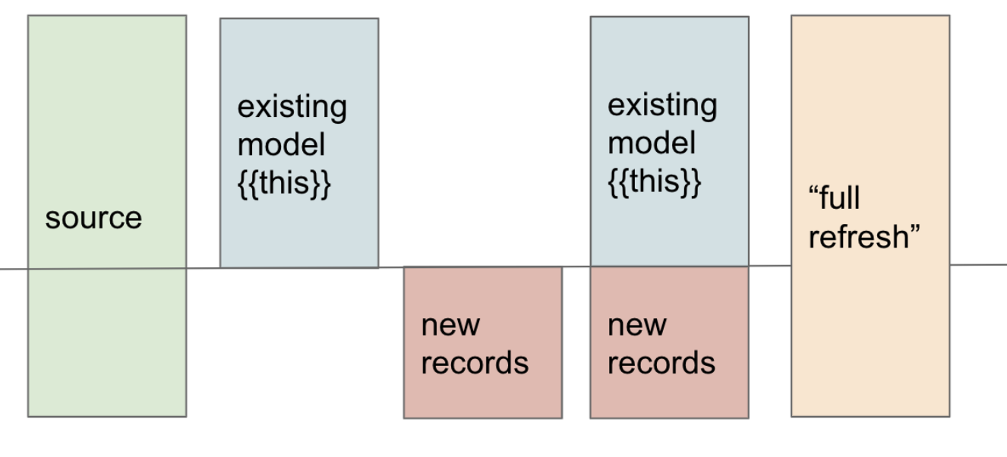

### **Create Model File**

models/customers.sql

SELECT

customer_id,

customer_name,

country

FROM raw.customers

### **Run dbt**

dbt run

📌 dbt will:

* Compile SQL
* Run it inside Snowflake
* Create a table/view

## **8️⃣ Use ref() for Dependencies (Best Practice)**

SELECT *

FROM {{ ref('customers') }}

✔ Manages dependencies  
✔ Enables lineage  
✔ Prevents hardcoding

## **9️⃣ Add Tests (Data Quality)**

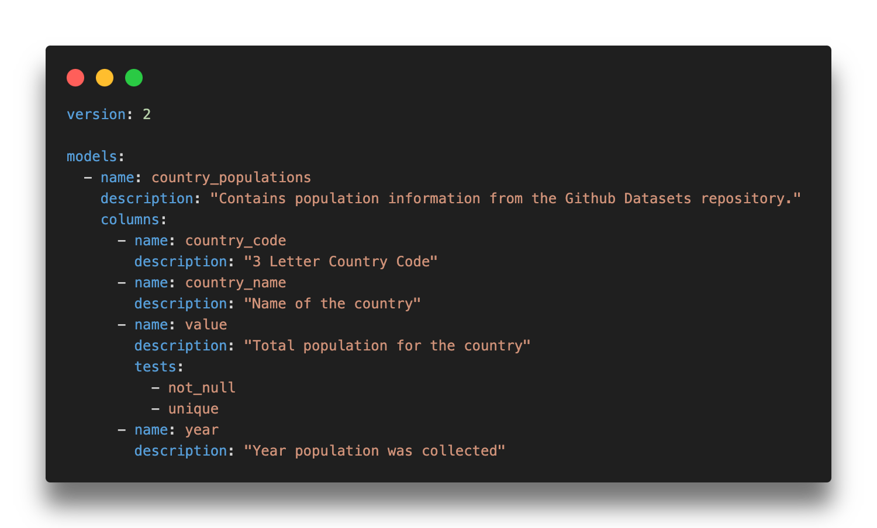

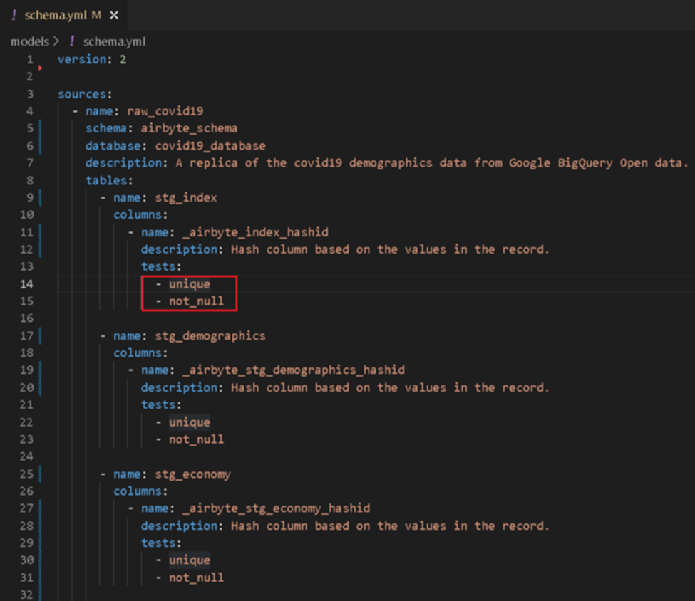



### **Create schema.yml**

models:

- name: customers

columns:

- name: customer_id

tests:

- not_null

- unique

### **Run Tests**

dbt test

✔ Ensures data quality  
✔ Prevents bad data in dashboards

## **🔟 Generate Documentation**

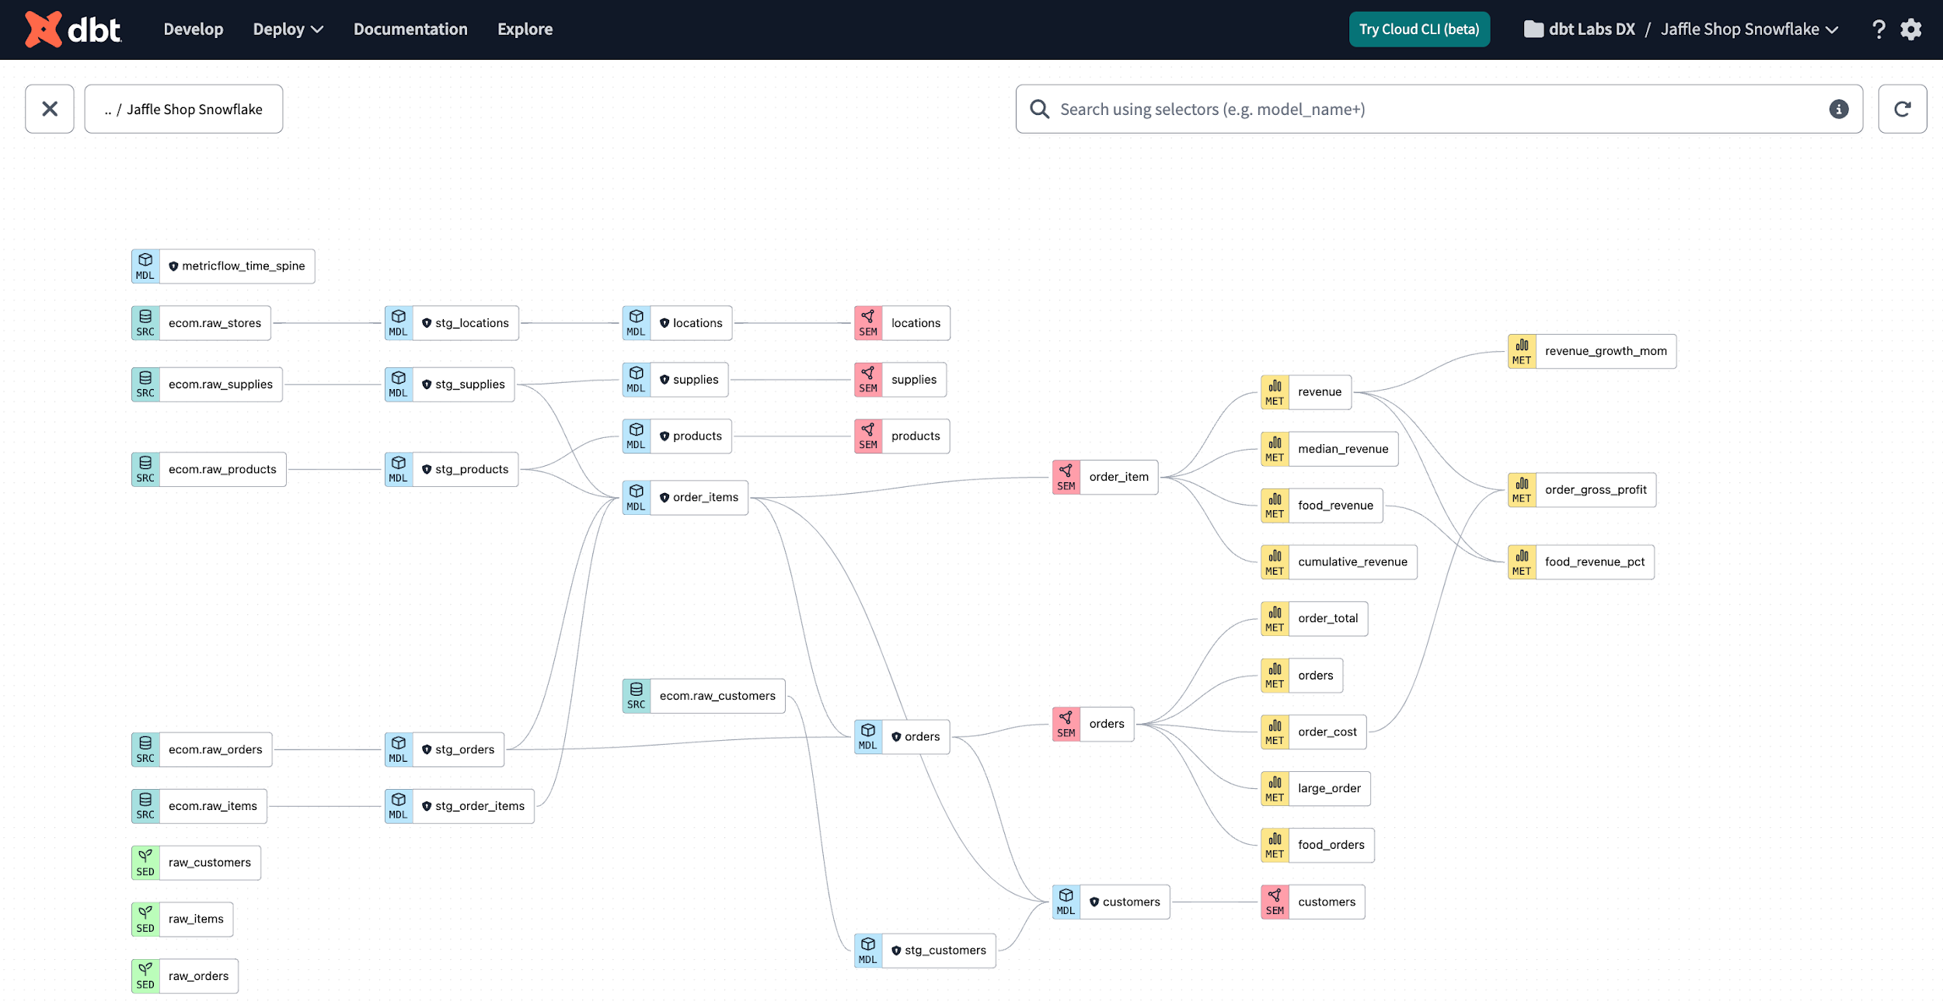

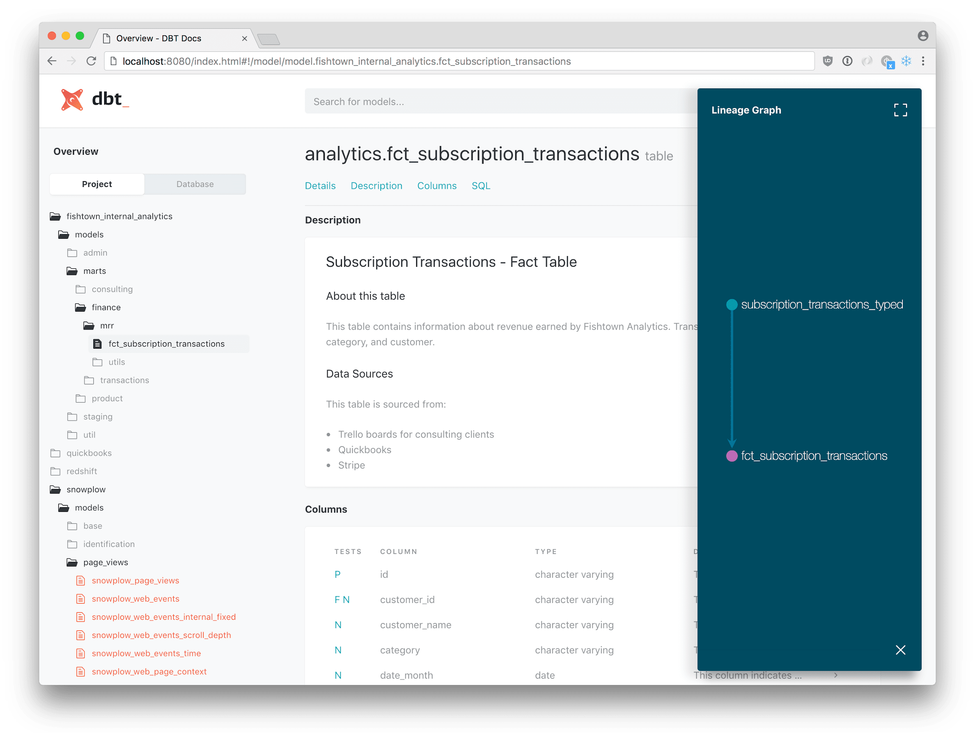

dbt docs generate

dbt docs serve

### **What You Get**

* Table & column descriptions
* Data lineage graph
* Dependencies visualization

## **1️⃣1️⃣ Environment Separation (Dev / Prod)**

targets:

dev:

schema: dbt_dev

prod:

schema: dbt_prod

Run in prod:

dbt run --target prod

## **1️⃣2️⃣ dbt + Snowflake Best Practices**

✔ Use **incremental models** for large tables  
✔ Use **XSMALL warehouses** for dbt  
✔ Separate **raw and analytics schemas**✔ Add tests on **primary keys & facts**✔ Use **CI/CD pipelines**

## **1️⃣3️⃣ Real Project Flow**

Git Commit → CI Runs dbt test → PR Approved →

dbt run (prod) → Snowflake Tables Updated

## **🎯 Interview One-Liners**

**How do you connect dbt to Snowflake?**

Using the dbt-snowflake adapter configured via profiles.yml.

**Where does dbt execute transformations?**

Inside Snowflake using Snowflake compute.

**Why dbt + Snowflake?**

Snowflake provides scalable compute, dbt provides governed SQL transformations.

## **📌 Final Summary**

✔ dbt is installed locally or via dbt Cloud  
✔ Snowflake handles compute & storage  
✔ dbt manages transformation logic  
✔ Best fit for modern ELT architecture

## **1️⃣ What is “Initialize dbt Project” in dbt Cloud?**

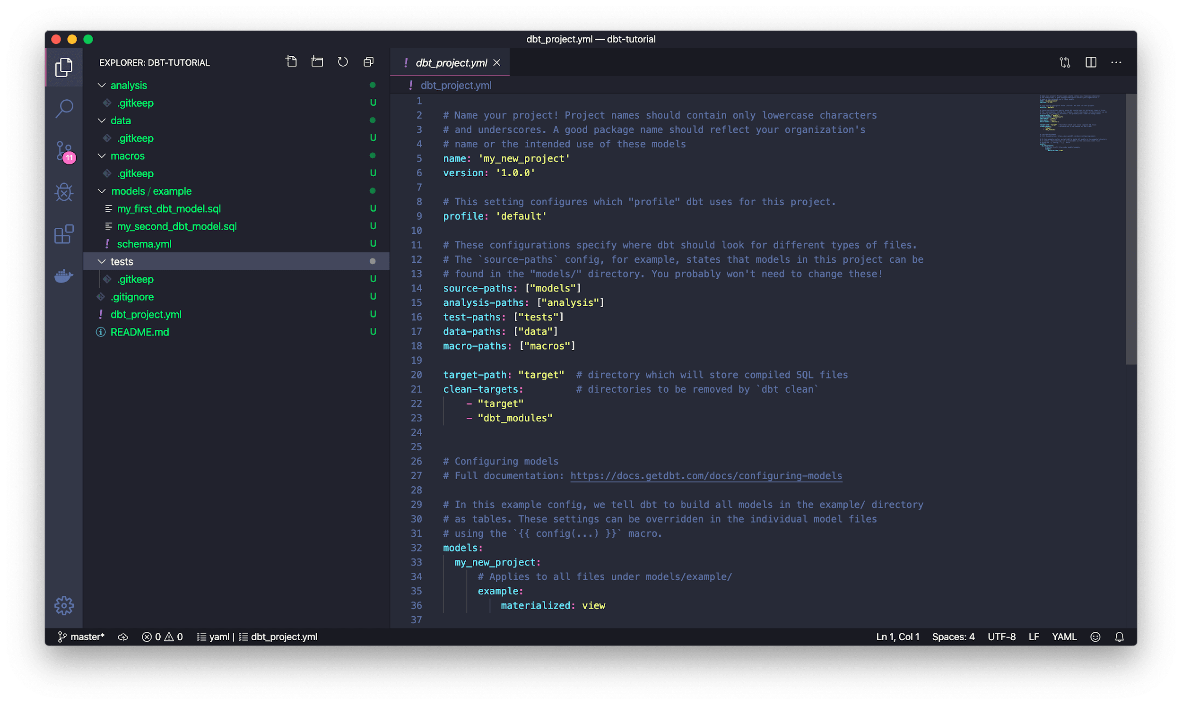



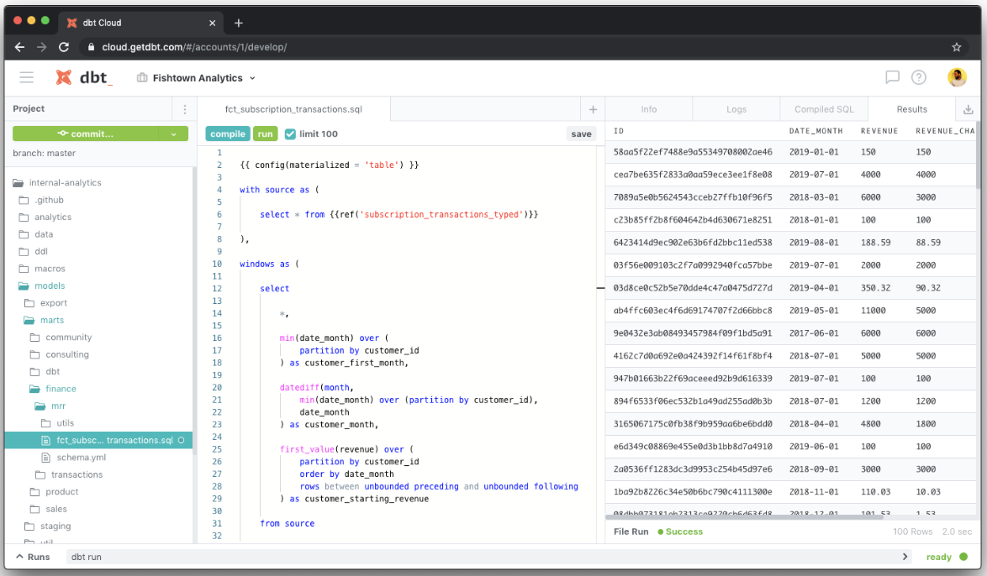

### **Definition**

**Initialize dbt project** is the step in **dbt Cloud** that **creates the basic dbt project structure** inside your connected Git repository.

It runs:

dbt init <project_name>

### **What it creates**

| **File / Folder** | **Purpose** |
| --- | --- |
| dbt_project.yml | Main project configuration |
| models/ | SQL models (transformations) |
| macros/ | Reusable SQL logic |
| tests/ | Generic & custom tests |
| seeds/ | Static CSV data |
| snapshots/ | Slowly changing dimensions |
| analyses/ | Ad-hoc SQL |
| README.md | Project documentation |

## **2️⃣ Why do we need Initialize dbt Project?**

### **Without initialization ❌**

* dbt Cloud **cannot run dbt**
* No project configuration
* No models or folder structure
* CI/CD jobs will fail

### **With initialization ✅**

* dbt knows **where models live**
* Enables:
  + dbt run
  + dbt test
  + dbt docs
* Enables:
  + Lineage
  + Documentation
  + CI/CD

### **Interview answer**

**Initialize dbt project sets up the required project structure and configuration so dbt Cloud can execute transformations and manage models.**

## **3️⃣ What is a Virtual Environment (venv)?**

### **Definition**

A **virtual environment** is an **isolated Python environment** that contains:

* dbt
* Adapter plugins (dbt-snowflake, dbt-bigquery, etc.)
* Project-specific dependencies

It avoids conflicts with:

* System Python
* Other projects’ libraries

## **4️⃣ Why do we need a Virtual Environment?**

### **Problem without venv ❌**

* Version conflicts
* dbt upgrade breaks other projects
* Different projects need different dbt versions

### **Benefits of venv ✅**

| **Benefit** | **Explanation** |
| --- | --- |
| Isolation | Each project has its own dependencies |
| Stability | Version-locked dbt |
| Reproducibility | Same behavior across dev, CI, prod |
| Clean upgrades | Safe dbt upgrades |

### **Interview one-liner**

**Virtual environments isolate dbt and its dependencies to avoid version conflicts and ensure consistent execution across environments.**

## **5️⃣ How to create a Virtual Environment (Local Machine)**

### **Step 1: Create venv**

python -m venv dbt_venv

### **Step 2: Activate venv**

**Windows**

dbt_venv\Scripts\activate

**Linux / Mac**

source dbt_venv/bin/activate

### **Step 3: Install dbt adapter**

pip install dbt-snowflake

### **Step 4: Verify**

dbt --version

## **6️⃣ Virtual Environment in dbt Cloud**

👉 **You do NOT create venv manually**

dbt Cloud:

* Automatically creates and manages:
  + Python environment
  + dbt version
  + Adapter plugins

You just select:

* dbt version
* Adapter (Snowflake, BigQuery, etc.)

## **7️⃣ Relation between Initialize Project & Virtual Env**

| **Feature** | **Local dbt** | **dbt Cloud** |
| --- | --- | --- |
| Initialize project | Manual | Button click |
| Virtual env | Manual | Auto-managed |
| Dependency mgmt | You manage | dbt Cloud manages |
| CI/CD ready | Extra setup | Built-in |

## **8️⃣ End-to-End Flow (dbt Cloud)**

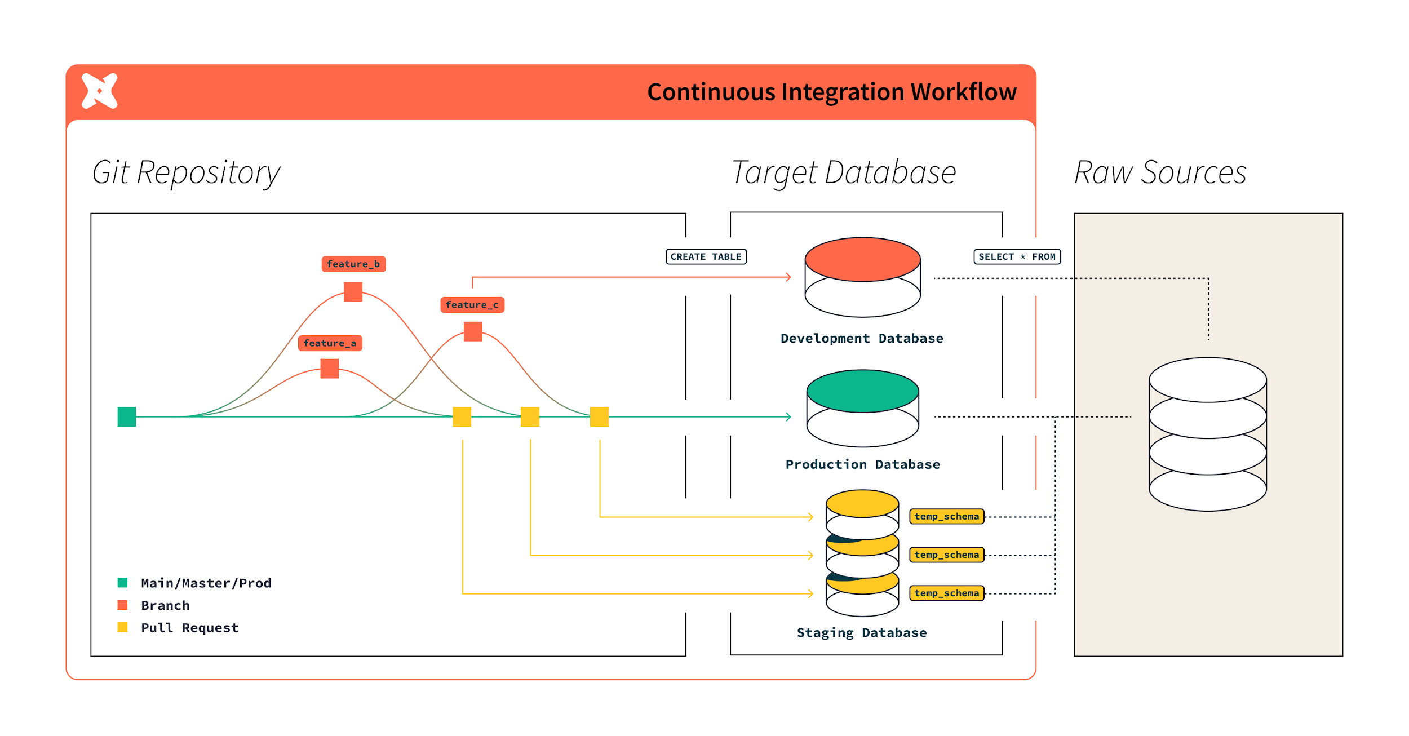

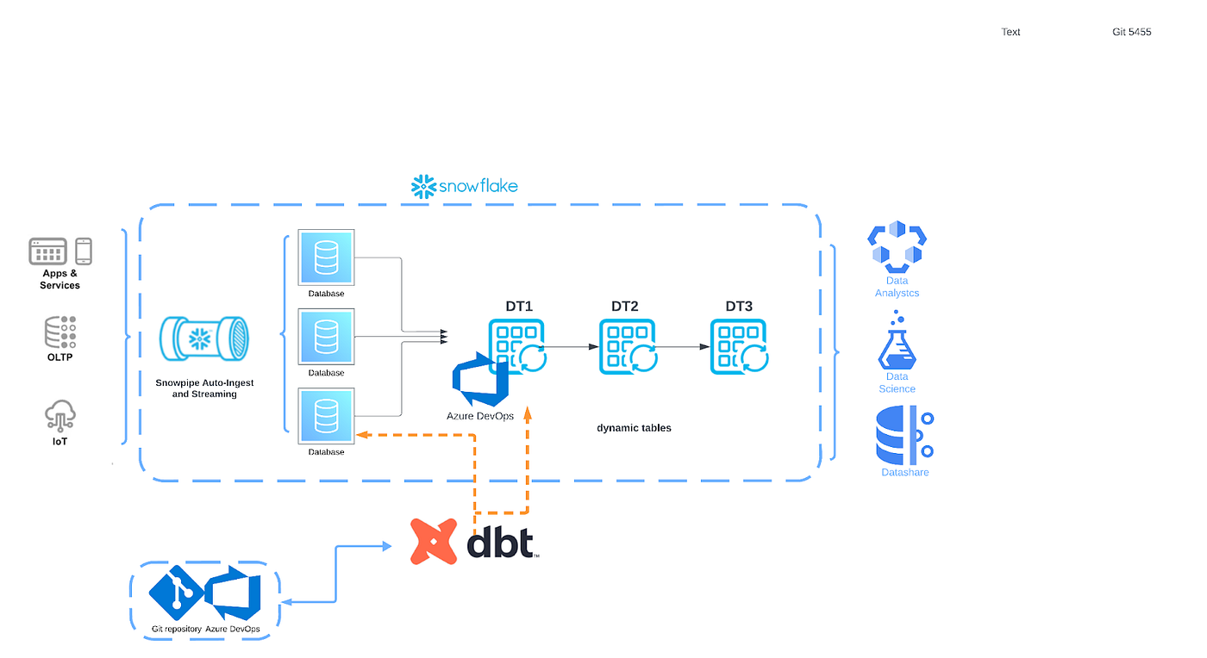

1. Connect Git repo
2. **Initialize dbt project**
3. Configure connection (Snowflake)
4. dbt Cloud creates **isolated environment**
5. Develop models
6. Run jobs / CI / docs

## **9️⃣ Interview-Ready Summary**

**Initialize dbt project creates the required project structure and configuration files for dbt to run. A virtual environment is used to isolate dbt and its dependencies to avoid version conflicts and ensure consistent execution. In dbt Cloud, the virtual environment is automatically managed, while locally we create it manually.**

## **dbt Cloud – Current Left Navigation (Latest UI)**

## **1️⃣ Catalog**

### **What it is**

The **Catalog** is the **central metadata layer** of dbt Cloud.

### **What you see here**

* All models, sources, snapshots
* Column details & data types
* Tests applied
* Ownership & descriptions
* Lineage (upstream & downstream)

### **Why it’s important**

* Single source of truth
* Impact analysis
* Data discovery for analysts & engineers

### **Interview line**

**Catalog provides a unified view of models, metadata, lineage, and data quality across the dbt project.**

## **2️⃣ Dashboard**

### **What it is**

A **high-level overview** of project health.

### **Shows**

* Recent job runs
* Failures & warnings
* Freshness issues
* Data quality trends

### **Why it’s useful**

* Quick health check
* Manager & lead friendly view

## **3️⃣ Studio ✅ (Selected in your image)**

### **What it is**

**Studio is the dbt Cloud IDE** (development environment).

### **What you do here**

* Write & edit:
  + Models
  + Macros
  + Tests
  + Snapshots
* Run dbt commands:
  + dbt run
  + dbt test
* View:
  + Compiled SQL
  + Logs
  + Lineage preview

### **Why Studio exists**

* No local setup needed
* Git-integrated development
* Safe dev environment

### **Interview line**

**Studio is the web-based IDE in dbt Cloud used for developing and testing dbt code.**

## **4️⃣ Canvas**

### **What it is**

**Canvas is a visual workspace** for understanding and designing data flows.

### **Used for**

* Visualizing transformations
* Exploring lineage in an interactive way
* Collaboration & planning

### **Why it matters**

* Easier understanding of complex DAGs
* Helpful for onboarding & design discussions

## **5️⃣ Insights**

### **What it is**

**Observability + analytics** for dbt runs and models.

### **Includes**

* Job performance metrics
* Model execution trends
* Failure analysis
* Test pass/fail history

### **Why it’s needed**

* Performance optimization
* Root-cause analysis
* SLA monitoring

### **Interview line**

**Insights provides analytical visibility into dbt job performance, reliability, and trends.**

## **6️⃣ Orchestration**

### **What it is**

This replaces the old **Jobs / Deploy** concept.

### **What you configure here**

* dbt jobs
* Schedules (cron / time-based)
* Environments (Dev, CI, Prod)
* Commands:
  + dbt run
  + dbt test
  + dbt build

### **Why it’s critical**

* Automates pipelines
* Production-grade execution
* CI/CD enablement

### **Interview line**

**Orchestration is used to schedule, manage, and execute dbt workflows across environments.**

## **7️⃣ Set up CLI**

### **What it is**

Guides you to **connect local dbt Core with dbt Cloud**.

### **Used for**

* Local development
* Using dbt Cloud credentials securely
* Hybrid workflow (local + cloud)

## **8️⃣ Leave feedback**

### **Purpose**

* Share product feedback with dbt Labs

## **9️⃣ Ask support assistant**

### **Purpose**

* Built-in help & troubleshooting
* dbt Cloud–specific questions

## **🔟 Get resources**

### **Includes**

* Documentation
* Learning paths
* Tutorials
* Best practices

## **1️⃣1️⃣ Organization name (Siemens)**

### **What it represents**

* Your dbt Cloud **organization**
* Used to manage:
  + Projects
  + Users
  + Permissions

## **1️⃣2️⃣ User profile (Shubham Tiwari)**

### **Used for**

* Account settings
* Preferences
* Logout

## **🔁 Mapping Old UI → New UI (Important for Interviews)**

| **Old UI** | **New UI** |
| --- | --- |
| Explore | Catalog |
| Jobs / Deploy | Orchestration |
| Observability | Insights |
| IDE | Studio |

## **🎯 One-Line Interview Summary**

**In the current dbt Cloud UI, Studio is used for development, Orchestration for scheduling and execution, Catalog for metadata and lineage, Insights for observability, Canvas for visual workflows, and Dashboard for overall project health.**

## **1️⃣ What is dbt_project.yml?**

### **Definition**

dbt_project.yml is the **main configuration file** of a dbt project.

It tells dbt:

* **What the project is**
* **Where files are located**
* **How models should be built**
* **Default behaviors for the project**

📌 Without this file, **dbt cannot run**.

## **2️⃣ Core Sections Explained (Using Your File)**

### **🔹 Project Identity**

name: 'my_new_project'

version: '1.0.0'

config-version: 2

| **Key** | **Meaning** |
| --- | --- |
| name | Project name (lowercase, underscores only) |
| version | Project version (for packages & releases) |
| config-version | dbt config schema version (always 2) |

✅ **Can we modify?**✔ Yes (especially name and version)  
⚠ Changing name requires updating references elsewhere.

### **🔹 Profile**

profile: 'default'

| **Purpose** |
| --- |
| Links dbt project to a **connection profile** |

* In **dbt Core** → defined in profiles.yml
* In **dbt Cloud** → defined in UI (this name must match)

✅ **Can modify** if you change connection profiles.

### **🔹 File & Folder Paths**

model-paths: ["models"]

analysis-paths: ["analyses"]

test-paths: ["tests"]

seed-paths: ["seeds"]

macro-paths: ["macros"]

snapshot-paths: ["snapshots"]

| **Path** | **Used for** |
| --- | --- |
| models | Transformations |
| analyses | Ad-hoc SQL |
| tests | Custom tests |
| seeds | Static CSV data |
| macros | Reusable logic |
| snapshots | SCD tracking |

✅ **Can modify** (advanced use cases)  
❌ Usually **not required**

### **🔹 Build & Clean Directories**

target-path: "target"

clean-targets:

- "target"

- "dbt_packages"

| **Key** | **Purpose** |
| --- | --- |
| target-path | Stores compiled SQL & artifacts |
| clean-targets | Deleted when dbt clean runs |

✅ Rarely modified  
📌 Used internally by dbt

## **3️⃣ Model Configuration Section (Most Important)**

### **Your config**

models:

my_new_project:

example:

+materialized: table

### **What this means**

Applies to models inside:  
models/example/

* Those models will be created as **tables**
* Other models default to **views**

### **Default Materialization Behavior**

| **Location** | **Materialization** |
| --- | --- |
| models/ | view (default) |
| models/example/ | table |

## **4️⃣ Can We Modify dbt_project.yml?**

👉 **YES, very commonly**

### **Common modifications**

### **✅ Change materialization**

+materialized: incremental

### **✅ Add schema name**

+schema: analytics

### **✅ Enable/disable models**

+enabled: false

## **5️⃣ Override Project Config in Model File**

Even if you set this in dbt_project.yml, you can override it inside a model:

{{ config(materialized='table') }}

select * from raw.sales;

📌 **Priority order**

1. Model file config (highest)
2. Folder config
3. Project default (lowest)

## **6️⃣ Advanced Options You Can Add**

### **Variables**

vars:

load_date: '2025-01-01'

### **Hooks**

on-run-start:

- "select 1"

### **Packages**

packages-install-path: dbt_packages

## **7️⃣ Common Mistakes (Interview Tip)**

❌ Uppercase project name  
❌ Indentation errors  
❌ Wrong profile name  
❌ Forgetting + in configs

## **8️⃣ Interview-Ready Summary**

**dbt_project.yml is the core configuration file of a dbt project that defines project metadata, file locations, connection profile, and default model behavior. It is highly configurable and allows controlling materializations, schemas, and execution settings at project or folder level, with the ability to override configurations at the model level.**

## **1️⃣ What is a dbt Model?**





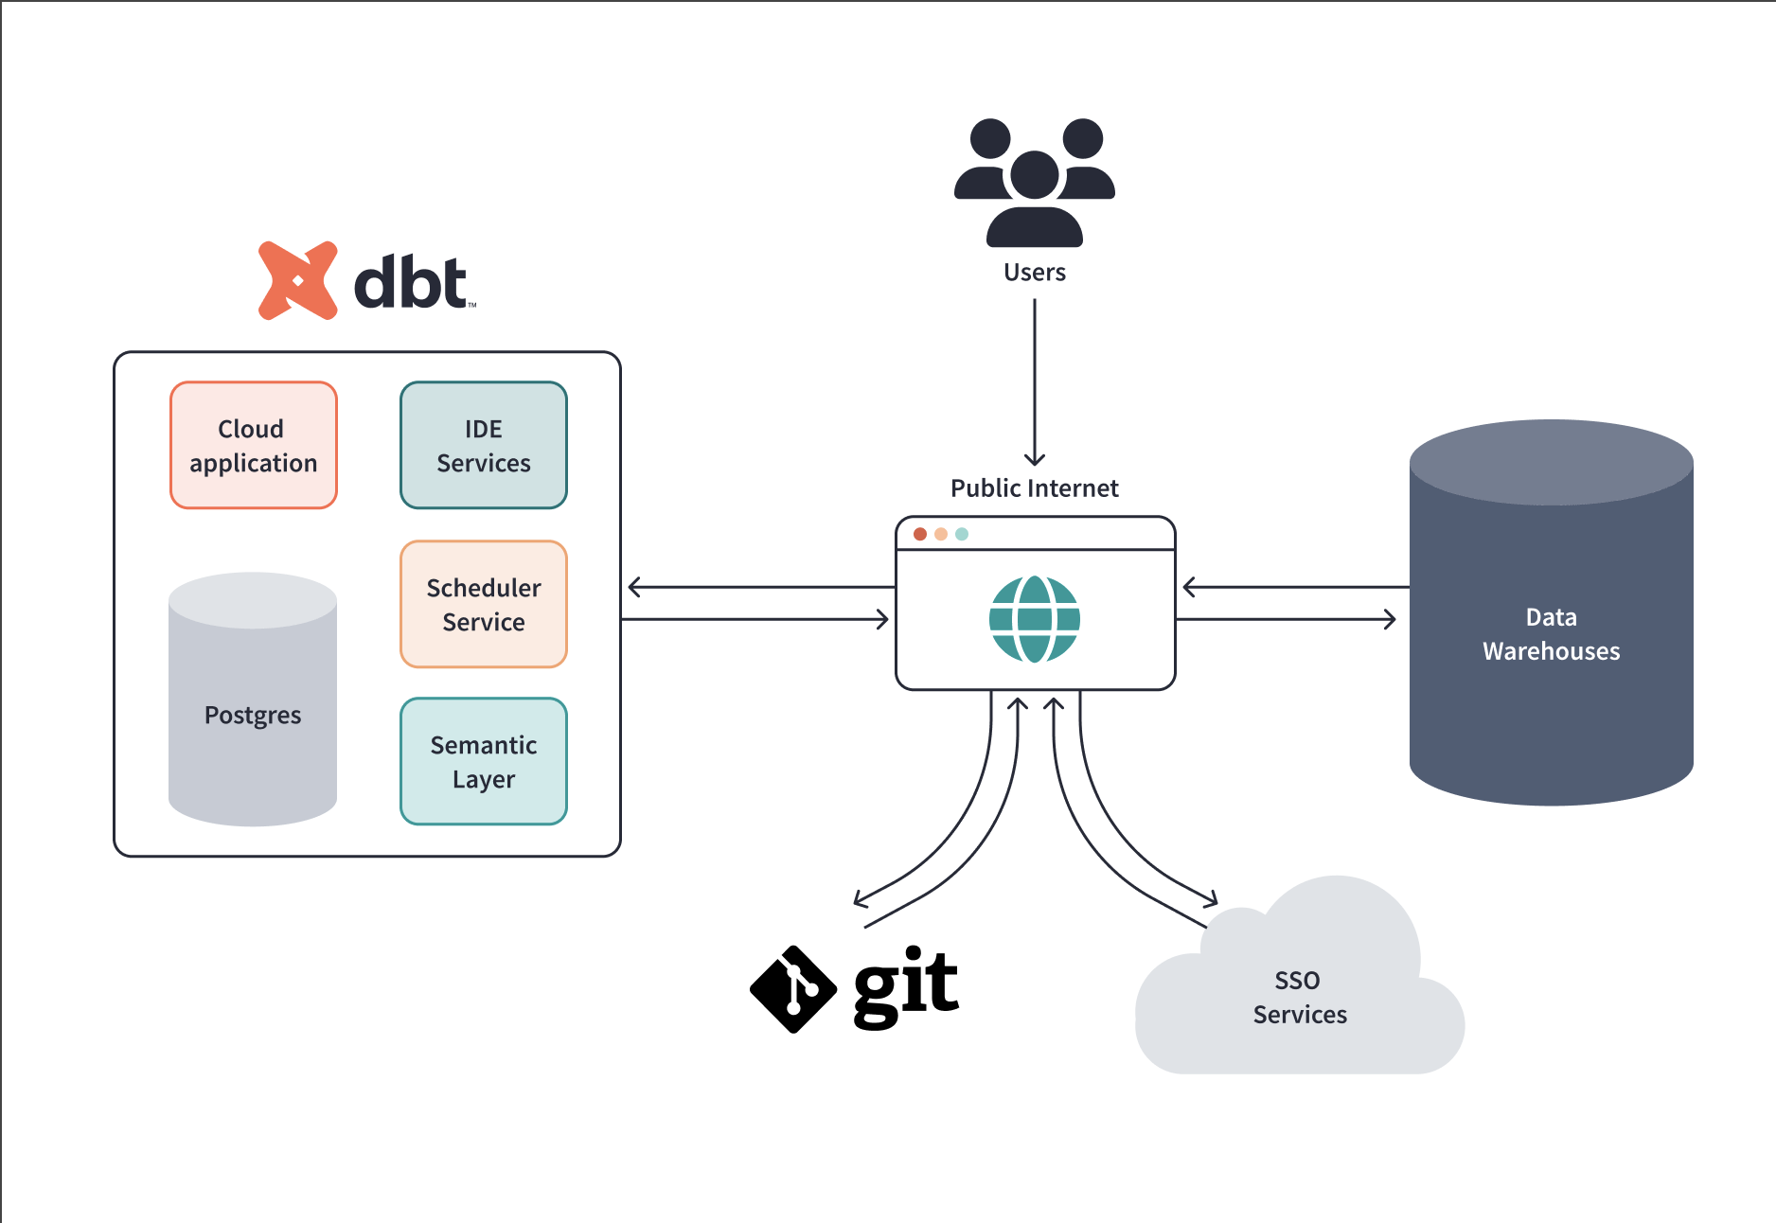

### **Definition**

A **dbt model** is a **SQL SELECT statement** saved as a .sql file inside the models/ folder that dbt **compiles and runs** in your data warehouse.

When you run dbt:

* dbt wraps your SQL
* Creates a **table / view / incremental table**
* Manages dependencies automatically

📌 **One model = one database object**

## **2️⃣ Why dbt Models are Important**

* Apply **ELT transformations**
* Build analytics-ready tables
* Maintain **data lineage**
* Enable **testing & documentation**
* Support **modular & reusable SQL**

## **3️⃣ Different Uses of dbt Models (with Examples)**

## **Use Case 1️⃣ Staging Models**

🧱 *Clean & standardize raw data*

### **Purpose**

* Rename columns
* Cast data types
* Remove duplicates
* Minimal logic

### **Example**

-- models/staging/stg_sales.sql

select

cast(order_id as int) as order_id,

to_date(order_date) as order_date,

upper(status) as status,

amount

from raw.sales

📌 **Best practice:**Prefix with stg_

## **Use Case 2️⃣ Intermediate Models**

🔗 *Join and transform multiple staging models*

### **Purpose**

* Join tables
* Apply business logic
* Keep transformations modular

### **Example**

-- models/intermediate/int_sales_customer.sql

select

s.order_id,

c.customer_name,

s.amount

from {{ ref('stg_sales') }} s

join {{ ref('stg_customers') }} c

on s.customer_id = c.customer_id

📌 Prefix: int_

## **Use Case 3️⃣ Mart / Fact Models**

📊 *Analytics-ready fact tables*

### **Purpose**

* Aggregations
* KPIs
* Reporting tables

### **Example**

-- models/marts/fact_sales.sql

select

order_date,

sum(amount) as total_sales,

count(order_id) as total_orders

from {{ ref('int_sales_customer') }}

group by order_date

📌 Prefix: fact_

## **Use Case 4️⃣ Dimension Models**

📘 *Descriptive attributes*

### **Purpose**

* Customer, product, date dimensions
* Used for slicing metrics

### **Example**

-- models/marts/dim_customer.sql

select

customer_id,

customer_name,

region

from {{ ref('stg_customers') }}

📌 Prefix: dim_

## **Use Case 5️⃣ Incremental Models**

⚡ *Process only new or changed data*

### **Purpose**

* Handle large datasets efficiently
* Improve performance

### **Example**

{{ config(materialized='incremental') }}

select *

from raw.sales

{% if is_incremental() %}

where order_date > (select max(order_date) from {{ this }})

{% endif %}

📌 Used for large fact tables

## **Use Case 6️⃣ Snapshot-Based Models (SCD-2)**

🕒 *Track historical changes*

### **Purpose**

* Track dimension changes
* Maintain history

### **Example**

-- models/marts/dim_customer_history.sql

select *

from {{ ref('customer_snapshot') }}

📌 Snapshot logic lives in snapshots/

## **Use Case 7️⃣ Ephemeral Models**

🧠 *Reusable SQL without creating tables*

### **Purpose**

* Avoid unnecessary objects
* Reuse logic inline

### **Example**

{{ config(materialized='ephemeral') }}

select

customer_id,

sum(amount) as total_spent

from {{ ref('stg_sales') }}

group by customer_id

📌 Compiled as CTEs

## **Use Case 8️⃣ Data Quality & Business Rule Models**

🛡️ *Validate data logic*

### **Purpose**

* Apply filters
* Business validations

### **Example**

select *

from {{ ref('fact_sales') }}

where total_sales < 0

Used with:

* Tests
* Alerts

## **4️⃣ Types of Materializations Used by Models**

| **Materialization** | **Use case** |
| --- | --- |
| view | Light transformations |
| table | Stable reporting tables |
| incremental | Large datasets |
| ephemeral | Temporary logic |
| materialized view | Real-time analytics |

## **5️⃣ Model Dependency (ref)**

select * from {{ ref('stg_sales') }}

✔ Enables:

* Automatic DAG
* Correct run order
* Impact analysis

## **6️⃣ Interview-Ready Summary**

**A dbt model is a SQL-based transformation that creates a table, view, or incremental object in the warehouse. dbt models are used for staging raw data, building intermediate transformations, creating fact and dimension tables, handling incremental loads, and applying business logic, all while enabling testing, documentation, and lineage.**

## **1️⃣ dbt run – Run models**

### **What it does**

Runs **only models** (no tests, no snapshots).

### **Command**

dbt run

### **Use when**

* You want to **build tables/views**
* Fast development iterations

## **2️⃣ Run a specific model**

🎯 *Most common in real projects*

dbt run --select stg_sales

### **Use when**

* Developing or debugging one model

## **3️⃣ Run a model with upstream dependencies**

⬆️

dbt run --select +stg_sales

* + before → run **parents**

### **Example use**

* Ensure sources & staging are up to date

## **4️⃣ Run a model with downstream dependencies**

⬇️

dbt run --select stg_sales+

* + after → run **children**

### **Example use**

* Validate impact of changes

## **5️⃣ Run full DAG (upstream + downstream)**

dbt run --select +stg_sales+

### **Use when**

* Major logic changes
* End-to-end validation

## **6️⃣ Run models by folder**

📁

dbt run --select models/staging

or

dbt run --select staging

### **Use when**

* Layer-wise execution (staging → marts)

## **7️⃣ Run models by tag**

🏷️

### **Tag in model**

{{ config(tags=['finance']) }}

### **Run**

dbt run --select tag:finance

### **Use when**

* Domain-based execution
* Partial pipelines

## **8️⃣ Run models by materialization**

🏗️

dbt run --select config.materialized:incremental

### **Use when**

* Running only large incremental models

## **9️⃣ Run models by schema**

🗄️

dbt run --select config.schema:analytics

## **🔟 dbt build – Recommended (Production)**

### **What it does**

Runs in this order:

1. Models
2. Tests
3. Snapshots
4. Seeds

dbt build

### **Use when**

* Production jobs
* CI/CD pipelines

### **Interview tip**

**dbt build is preferred over dbt run in production.**

## **1️⃣1️⃣ Run with exclude**

❌

dbt run --exclude stg_customers

### **Use when**

* Skip broken or heavy models

## **1️⃣2️⃣ Run by state selection**

🧠 (Advanced)

dbt run --select state:modified+

### **Use when**

* CI pipelines
* Run only changed models

## **1️⃣3️⃣ Run Incremental models in full refresh**

🔄

dbt run --select fact_sales --full-refresh

### **Use when**

* Logic changes
* Data backfill

## **1️⃣4️⃣ Run via dbt Cloud Orchestration**

☁️







### **How**

* Create Job
* Choose command:
  + dbt run
  + dbt build
* Set schedule

### **Use when**

* Automated pipelines
* Production runs

## **🧠 Quick Comparison**

| **Command** | **What runs** | **Use case** |
| --- | --- | --- |
| dbt run | Models only | Development |
| dbt build | Models + tests + snapshots | Production |
| dbt test | Tests only | Validation |
| dbt run-operation | Macros | Admin tasks |

## **🎯 Interview-Ready Summary**

**dbt models can be run using dbt run, dbt build, model selection syntax, tags, folders, dependencies, and through dbt Cloud orchestration jobs. In production, dbt build is preferred for end-to-end reliability.**

## **1️⃣ What is schema.yml (or schema.yaml)?**

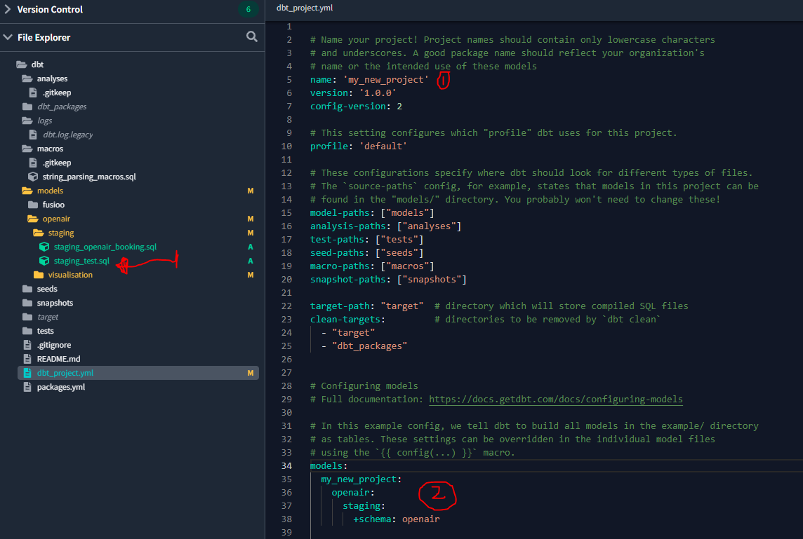

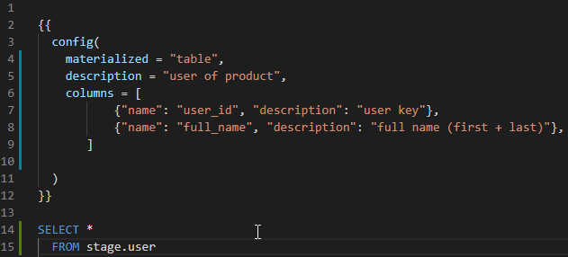



### **Definition**

schema.yml is a **YAML configuration file** in dbt used to:

* **Document models and columns**
* **Define data tests**
* **Declare sources**
* **Define exposures & metrics** (modern dbt)

📌 It contains **metadata**, not SQL logic.

## **2️⃣ Why do we need schema.yml?**

Without schema.yml ❌

* No documentation
* No column-level tests
* Poor data trust
* Harder impact analysis

With schema.yml ✅

* Auto-generated docs
* Data quality checks
* Governance & ownership
* Lineage visibility

### **Interview line**

**schema.yml is used in dbt to define documentation, tests, and metadata for models and sources.**

## **3️⃣ Where is schema.yml stored?**

Typically inside:

models/

staging/

schema.yml

marts/

schema.yml

📌 One schema.yml can describe **multiple models**.

## **4️⃣ Different Use Cases of schema.yml (with Examples)**

## **Use Case 1️⃣ Model Documentation**

### **Purpose**

Describe **what a model represents**.

version: 2

models:

- name: fact_sales

description: "Fact table containing daily sales metrics"

## **Use Case 2️⃣ Column Documentation**

### **Purpose**

Explain **meaning of each column**.

models:

- name: fact_sales

columns:

- name: order_date

description: "Date on which the order was placed"

📌 Appears in dbt Docs & Catalog.

## **Use Case 3️⃣ Column-Level Tests**

### **Purpose**

Validate data quality.

models:

- name: fact_sales

columns:

- name: order_id

tests:

- not_null

- unique

✔ Runs with:

dbt test

## **Use Case 4️⃣ Model-Level Tests**

### **Purpose**

Apply tests on the entire table.

models:

- name: fact_sales

tests:

- dbt_utils.expression_is_true:

expression: "total_sales >= 0"

## **Use Case 5️⃣ Source Definition (Very Important)**

### **Purpose**

Declare **raw data sources** and test them.

sources:

- name: raw

database: sales_db

schema: raw_schema

tables:

- name: sales

description: "Raw sales data from source system"

columns:

- name: order_id

tests:

- not_null

Referenced in models:

select * from {{ source('raw', 'sales') }}

## **Use Case 6️⃣ Source Freshness Checks**

### **Purpose**

Ensure data arrives on time.

sources:

- name: raw

tables:

- name: sales

freshness:

warn_after: {count: 12, period: hour}

error_after: {count: 24, period: hour}

✔ Run:

dbt source freshness

## **Use Case 7️⃣ Relationships (Foreign Key Tests)**

### **Purpose**

Validate joins between models.

models:

- name: fact_sales

columns:

- name: customer_id

tests:

- relationships:

to: ref('dim_customer')

field: customer_id

## **Use Case 8️⃣ Exposures (Who Uses the Data)**

### **Purpose**

Track downstream usage (dashboards, ML).

exposures:

- name: sales_dashboard

type: dashboard

owner:

name: BI Team

depends_on:

- ref('fact_sales')

📌 Helps with impact analysis.

## **Use Case 9️⃣ Metrics (Modern dbt)**

### **Purpose**

Define **business metrics once**.

metrics:

- name: total_sales

model: ref('fact_sales')

calculation_method: sum

expression: amount

## **5️⃣ Can We Modify schema.yml?**

👉 **Yes, very frequently**

### **You can:**

* Add/remove tests
* Update descriptions
* Add ownership
* Add freshness rules

⚠️ YAML indentation must be correct.

## **6️⃣ Difference: schema.yml vs dbt_project.yml**

| **Feature** | **schema.yml** | **dbt_project.yml** |
| --- | --- | --- |
| Purpose | Docs & tests | Project config |
| SQL logic | ❌ No | ❌ No |
| Model behavior | ❌ No | ✅ Yes |
| Data quality | ✅ Yes | ❌ No |

## **7️⃣ Interview-Ready Summary**

**schema.yml is a metadata file in dbt used to define documentation, tests, sources, freshness checks, and exposures. It improves data quality, governance, and lineage while enabling auto-generated documentation.**

## **1️⃣ What is Materialization in dbt?**



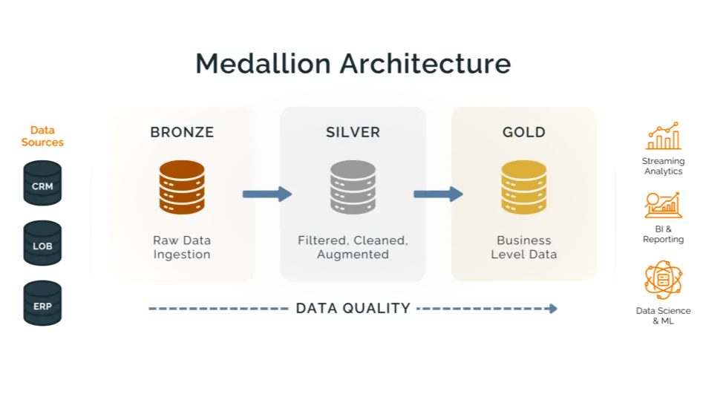

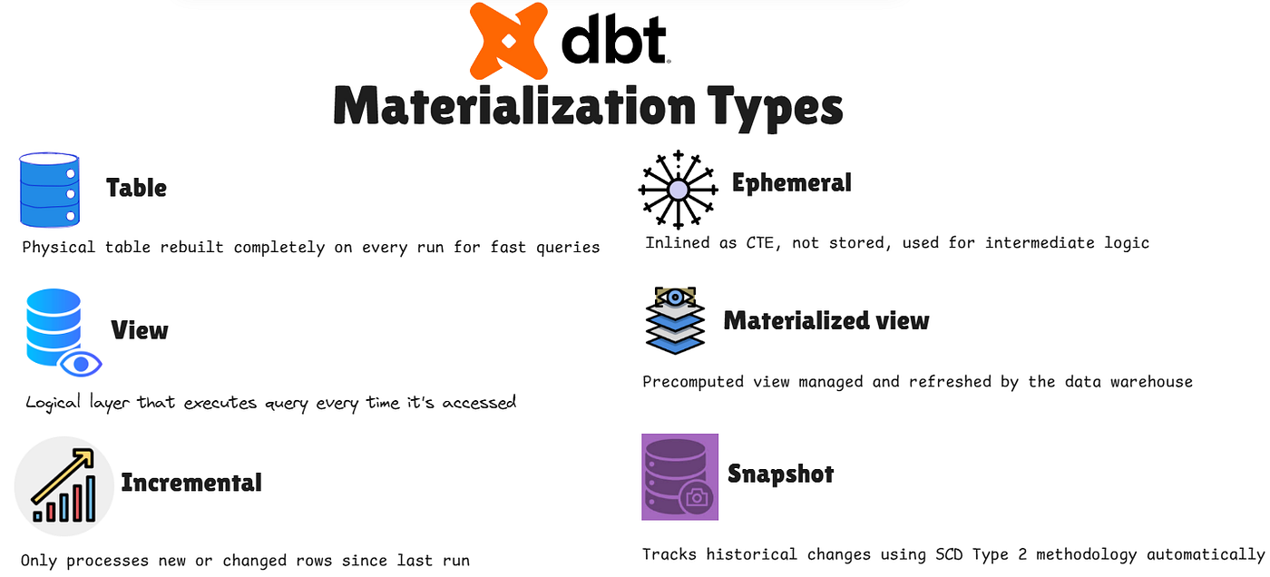

### **Definition**

**Materialization** defines **how a dbt model is stored** in the data warehouse when it runs.

Each dbt model can be materialized as:

* **view**
* **table**
* **incremental**
* **ephemeral** (not asked here)

## **2️⃣ Materializing Models at Model Level**

👉 Model-level configuration is done using the config() macro **inside the SQL file**.

📌 **Model-level config overrides project-level config**

## **3️⃣ Materialize as VIEW**

### **When to use**

* Lightweight transformations
* Staging layer
* Fast refresh required

### **Example**

-- models/staging/stg_sales.sql

{{ config(materialized='view') }}

select

order_id,

order_date,

amount

from raw.sales;

### **Result in warehouse**

* A **VIEW** is created
* Always reflects latest data

## **4️⃣ Materialize as TABLE**

### **When to use**

* Final reporting tables
* Stable data
* Performance-critical queries

### **Example**

-- models/marts/fact_sales.sql

{{ config(materialized='table') }}

select

order_date,

sum(amount) as total_sales

from {{ ref('stg_sales') }}

group by order_date;

### **Result**

* A **TABLE** is created
* Fully rebuilt on every run

## **5️⃣ Materialize as INCREMENTAL**

### **When to use**

* Large datasets
* Append-only or slowly changing data
* Avoid full refresh every run

### **Basic Incremental Example**

-- models/marts/fact_sales.sql

{{ config(materialized='incremental') }}

select *

from raw.sales

{% if is_incremental() %}

where order_date > (select max(order_date) from {{ this }})

{% endif %}

### **How it works**

| **First run** | **Full load** |
| --- | --- |
| Next runs | Only new records |

### **Full Refresh (if needed)**

dbt run --select fact_sales --full-refresh

## **6️⃣ Summary: Materialization Types**

| **Materialization** | **Stored as** | **Use case** |
| --- | --- | --- |
| view | View | Staging |
| table | Table | Facts & dimensions |
| incremental | Table (partial load) | Large fact tables |

## **7️⃣ Defining Schemas (Bronze / Silver / Gold)**

### **Concept**

Schemas represent **data layers**:

| **Layer** | **Purpose** |
| --- | --- |
| Bronze | Raw / ingestion |
| Silver | Cleaned & standardized |
| Gold | Business-ready |

## **8️⃣ Define Schema at Model Level**

### **Bronze Example**

-- models/bronze/raw_sales.sql

{{ config(

materialized='view',

schema='bronze'

) }}

select * from raw.sales;

### **Silver Example**

-- models/silver/stg_sales.sql

{{ config(

materialized='view',

schema='silver'

) }}

select

order_id,

cast(order_date as date) as order_date,

amount

from {{ ref('raw_sales') }};

### **Gold Example**

-- models/gold/fact_sales.sql

{{ config(

materialized='table',

schema='gold'

) }}

select

order_date,

sum(amount) as total_sales

from {{ ref('stg_sales') }}

group by order_date;

## **9️⃣ Schema Creation – Important Note**

📌 dbt **automatically creates schemas** if:

* User has permission
* Schema does not exist

No manual DDL required.

## **🔟 Alternative: Schema by Folder (Best Practice)**

Instead of repeating config in every model 👇

### **dbt_project.yml**

models:

my_project:

bronze:

+schema: bronze

+materialized: view

silver:

+schema: silver

+materialized: view

gold:

+schema: gold

+materialized: table

📁 Folder structure:

models/

bronze/

silver/

gold/

✅ Cleaner  
✅ Scalable  
✅ Production-ready

## **1️⃣1️⃣ Priority Order (Important for Interview)**

1. Model-level config
2. Folder-level config
3. Project-level default

## **🎯 Interview-Ready Summary**

**dbt models can be materialized as views, tables, or incremental tables using the config macro at model level. Views are used for staging, tables for reporting, and incremental models for large datasets. Schemas such as bronze, silver, and gold can be defined either at model level or folder level to implement a layered data architecture.**

Bhh

## **1️⃣ What is ref() function in dbt?**

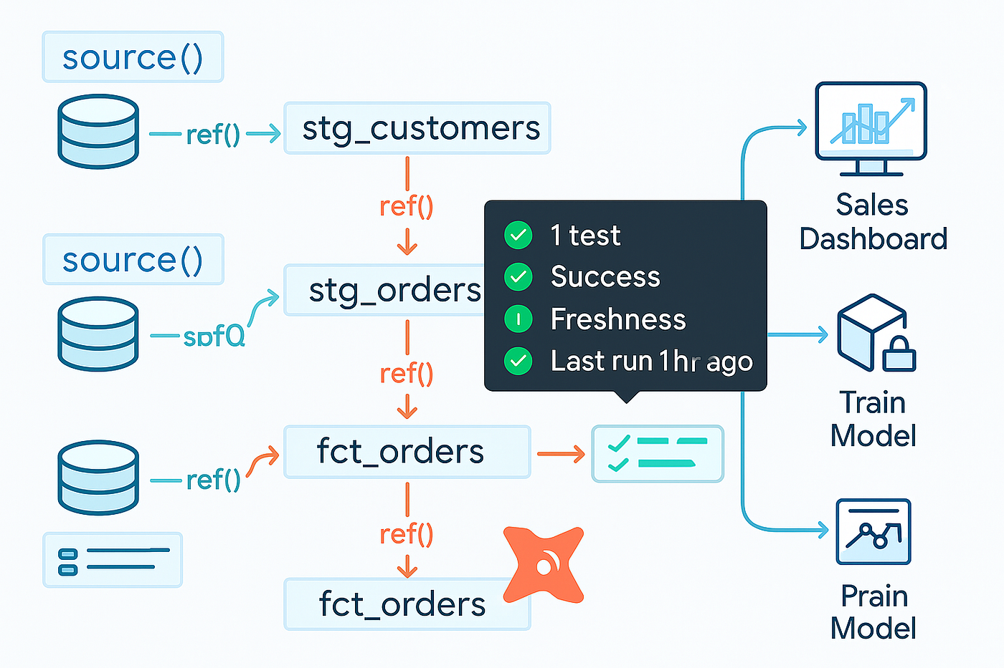

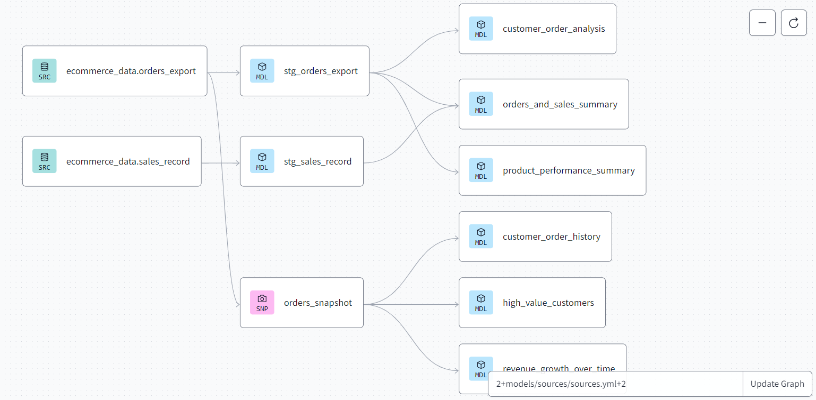

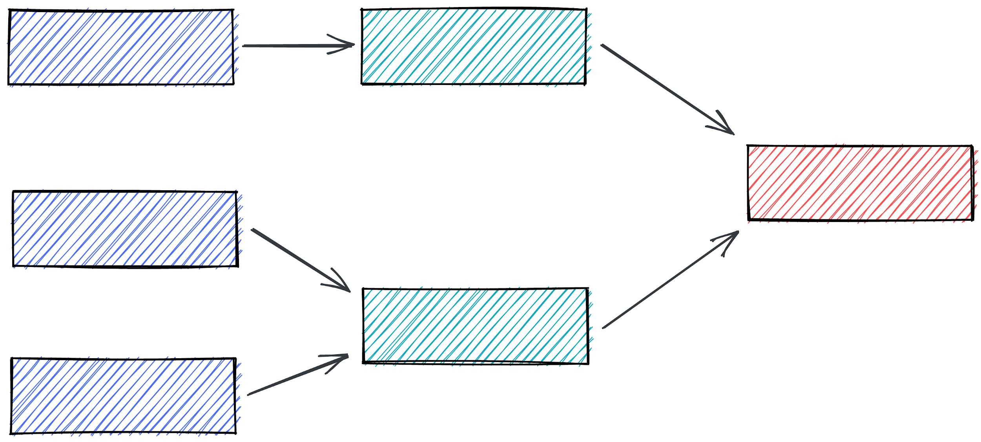

### **Definition**

ref() is a **built-in dbt Jinja function** used to **reference another dbt model**.

{{ ref('model_name') }}

📌 You **do not create** the ref() function yourself — dbt provides it.

## **2️⃣ Why do we use ref()?**

Using ref() tells dbt:

1. **Dependency order** (which model runs first)
2. **Correct schema & database resolution**
3. **Lineage (DAG) creation**
4. **Safe refactoring** (renames don’t break SQL)

### **Interview one-liner**

**ref() creates dependencies between dbt models and enables automatic DAG generation and environment-aware table resolution.**

## **3️⃣ What happens if we don’t use ref()?**

❌ Hard-coding table names:

select * from silver.stg_sales

Problems:

* No lineage
* Wrong order of execution
* Breaks in different environments
* Renaming models causes failures

✅ Correct approach:

select * from {{ ref('stg_sales') }}

## **4️⃣ How to use ref() (Step-by-Step)**

### **Step 1️⃣ Create a model**

-- models/silver/stg_sales.sql

select * from raw.sales

### **Step 2️⃣ Reference it using ref()**

-- models/gold/fact_sales.sql

select

order_date,

sum(amount) as total_sales

from {{ ref('stg_sales') }}

group by order_date

### **Step 3️⃣ Run dbt**

dbt run

dbt will:

* Run stg_sales first
* Then run fact_sales
* Build lineage automatically

## **5️⃣ How dbt resolves ref()**

When compiled:

{{ ref('stg_sales') }}

Becomes:

DATABASE.SILVER.STG_SALES

(Depends on environment & schema config)

## **6️⃣ ref() with schema layers (bronze/silver/gold)**

select *

from {{ ref('dim_customer') }}

Even if:

* Dev → dev_silver.dim_customer
* Prod → prod_silver.dim_customer

👉 **No code change needed**

## **7️⃣ ref() with Packages**

select *

from {{ ref('date_spine') }}

* Works for models in:
  + Your project
  + Installed dbt packages

## **8️⃣ ref() vs source()**

| **Function** | **Used for** |
| --- | --- |
| ref() | dbt-managed models |
| source() | Raw/external tables |

### **Example**

select * from {{ source('raw', 'sales') }}

## **9️⃣ Common Mistakes (Interview Tip)**

❌ Typo in model name  
❌ Using schema.table instead of ref()  
❌ Circular dependencies

## **🔟 Lineage Example (Logical Flow)**

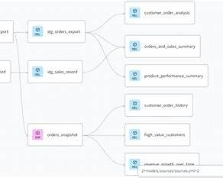

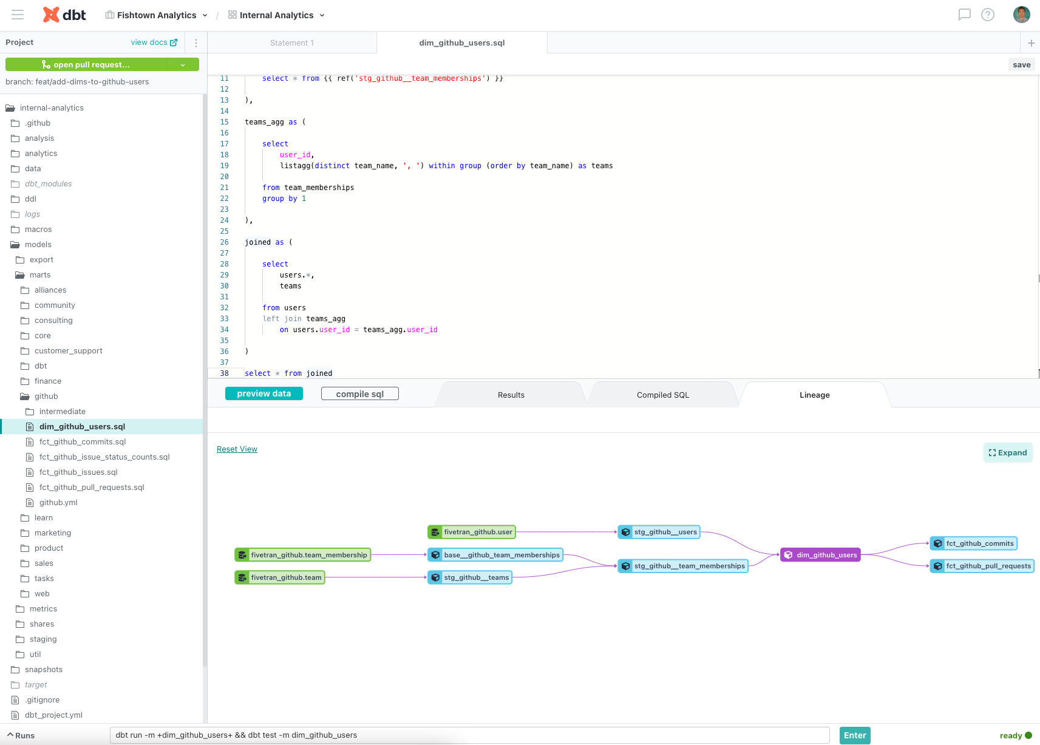

raw.sales

↓

stg_sales

↓

fact_sales

## **🎯 Interview-Ready Summary**

**ref() is a built-in dbt function used to reference other dbt models. It establishes dependencies, ensures correct execution order, enables lineage, and dynamically resolves schema and database names across environments.**

# **📘 dbt Notes: Schema Name Change**

## **1️⃣ What is a Schema Name in dbt?**

### **Definition**

A **schema** in dbt represents a **logical database layer** where models are created, such as:

* bronze
* silver
* gold
* analytics
* reporting

In Snowflake:

DATABASE.SCHEMA.TABLE

dbt controls the **SCHEMA** part.

## **2️⃣ Why Do We Change Schema Names?**

### **Common reasons**

* Implement **Bronze / Silver / Gold architecture**
* Separate **Dev / QA / Prod** environments
* Improve **data governance**
* Avoid mixing raw & curated data
* Team or domain isolation

### **Interview line**

**Schema name changes in dbt are used to logically separate data layers, environments, and business domains.**

## **3️⃣ Ways to Change Schema Name in dbt**

There are **4 main ways**, ordered from **most common to advanced**.

## **4️⃣ Method 1: Change Schema at Model Level**

### **How**

Use config(schema=...) inside the model.

### **Example**

-- models/gold/fact_sales.sql

{{ config(

materialized='table',

schema='gold'

) }}

select * from {{ ref('stg_sales') }};

### **Result**

DATABASE.GOLD.FACT_SALES

### **When to use**

* Quick override
* Special models

⚠️ Not scalable for large projects

## **5️⃣ Method 2: Change Schema at Folder Level (Best Practice)**

### **dbt_project.yml**

models:

my_project:

bronze:

+schema: bronze

+materialized: view

silver:

+schema: silver

+materialized: view

gold:

+schema: gold

+materialized: table

### **Folder structure**

models/

bronze/

silver/

gold/

### **Result**

* All models in gold/ → gold schema

### **Why this is best**

* Clean
* Scalable
* Enterprise standard

## **6️⃣ Method 3: Environment-Specific Schema (Dev / Prod)**

### **dbt behavior (default)**

dbt automatically prefixes schema in dev:

dev_shubham_gold

prod_gold

Controlled by:

* dbt Cloud environment
* Target schema settings

### **Example**

Dev:

DEV_SHUBHAM_GOLD.FACT_SALES

Prod:

PROD_GOLD.FACT_SALES

## **7️⃣ Method 4: Custom Schema Naming using generate_schema_name**

### **What is this?**

A **macro override** to fully control schema naming logic.

### **Create macro**

📁 macros/generate_schema_name.sql

{% macro generate_schema_name(custom_schema_name, node) %}

{% if target.name == 'prod' %}

{{ custom_schema_name }}

{% else %}

{{ target.name }}_{{ custom_schema_name }}

{% endif %}

{% endmacro %}

### **Result**

| **Environment** | **Schema** |
| --- | --- |
| Dev | dev_gold |
| Prod | gold |

### **Interview tip**

This is widely used in **production dbt projects**.

## **8️⃣ Automatic Schema Creation**

📌 dbt **automatically creates schemas** if:

* Schema does not exist
* User has CREATE SCHEMA permission

No manual DDL needed.

## **9️⃣ Priority Order (Very Important)**

dbt resolves schema in this order:

1. **Model-level config**
2. **Folder-level config**
3. **generate_schema_name macro**
4. **Default target schema**

## **🔟 Common Mistakes**

❌ Hardcoding schema names in SQL  
❌ Using database.schema.table instead of ref()  
❌ Mixing environments in same schema  
❌ Incorrect YAML indentation

## **1️⃣1️⃣ Real-World Example (Bronze → Silver → Gold)**

| **Layer** | **Schema** | **Materialization** |
| --- | --- | --- |
| Bronze | bronze | view |
| Silver | silver | view |
| Gold | gold | table |

## **🎯 Interview-Ready Summary**

**Schema name changes in dbt allow logical separation of data layers and environments. Schemas can be defined at model level, folder level, or dynamically using the generate_schema_name macro. Folder-level configuration combined with custom schema naming macros is the recommended production approach.**

# **📘 dbt Notes: schema.yml**

## **1️⃣ What is schema.yml?**

schema.yml is a **YAML metadata file** in dbt used to **document data models**, **define tests**, **declare sources**, and **describe downstream usage** (exposures/metrics).

📌 It contains **no SQL logic**—only **documentation, tests, and metadata**.

## **2️⃣ Why do we need schema.yml?**

* 📚 **Auto-generate documentation** (dbt Docs / Catalog)
* 🛡️ **Enforce data quality** with tests
* 🧭 **Enable lineage & impact analysis**
* 🏷️ **Add ownership & governance**
* ⏱️ **Monitor freshness of source data**

**Interview one-liner:**

**schema.yml centralizes documentation, tests, and metadata to improve data quality, trust, and discoverability.**

## **3️⃣ Where does schema.yml live?**

Typically under models/ (can be multiple files):

models/

staging/

schema.yml

marts/

schema.yml

📌 One schema.yml can document **many models/sources**.

## **4️⃣ Basic Structure**

version: 2

models:

- name: model_name

description: "What this model represents"

columns:

- name: column_name

description: "What this column means"

tests:

- not_null

## **5️⃣ Key Use Cases (with Examples)**

### **Use Case 1️⃣ Model Documentation**

version: 2

models:

- name: fact_sales

description: "Daily aggregated sales facts"

### **Use Case 2️⃣ Column Documentation**

models:

- name: fact_sales

columns:

- name: order_date

description: "Date the order was placed"

### **Use Case 3️⃣ Column-Level Tests**

models:

- name: fact_sales

columns:

- name: order_id

tests:

- not_null

- unique

Run with:

dbt test

### **Use Case 4️⃣ Model-Level Tests**

models:

- name: fact_sales

tests:

- dbt_utils.expression_is_true:

expression: "total_sales >= 0"

### **Use Case 5️⃣ Source Definitions (Very Important)**

sources:

- name: raw

database: sales_db

schema: raw_schema

tables:

- name: sales

description: "Raw sales from source system"

columns:

- name: order_id

tests:

- not_null

Reference in models:

select * from {{ source('raw', 'sales') }}

### **Use Case 6️⃣ Source Freshness Checks**

sources:

- name: raw

tables:

- name: sales

freshness:

warn_after: {count: 12, period: hour}

error_after: {count: 24, period: hour}

Run:

dbt source freshness

### **Use Case 7️⃣ Relationships (FK Tests)**

models:

- name: fact_sales

columns:

- name: customer_id

tests:

- relationships:

to: ref('dim_customer')

field: customer_id

### **Use Case 8️⃣ Exposures (Who Uses the Data)**

exposures:

- name: sales_dashboard

type: dashboard

owner:

name: BI Team

email: bi@company.com

depends_on:

- ref('fact_sales')

### **Use Case 9️⃣ Metrics (Modern dbt)**

metrics:

- name: total_sales

model: ref('fact_sales')

calculation_method: sum

expression: amount

## **6️⃣ Generic vs Singular Tests**

* **Generic tests**: Declared in schema.yml (e.g., not_null, unique)
* **Singular tests**: SQL files under tests/ returning failing rows

## **7️⃣ Best Practices**

* Keep **descriptions concise and business-friendly**
* Add **tests to key columns** (PKs, FKs, dates)
* Define **sources + freshness** for ingestion monitoring
* Use **ownership** for accountability
* Validate YAML indentation (common pitfall)

## **8️⃣ schema.yml vs dbt_project.yml**

| **Aspect** | **schema.yml** | **dbt_project.yml** |
| --- | --- | --- |
| Purpose | Docs, tests, metadata | Project configuration |
| SQL logic | ❌ | ❌ |
| Model behavior | ❌ | ✅ |
| Data quality | ✅ | ❌ |

## **9️⃣ Interview-Ready Summary**

**schema.yml is a dbt metadata file used to document models and columns, define data tests, declare sources with freshness checks, and capture downstream usage via exposures and metrics. It improves data quality, governance, and discoverability without containing SQL logic.**

If you want, I can also:

* Share a **real production schema.yml**
* Explain **tests priority & failure handling**
* Create a **1-page revision sheet**

# **📘 dbt Notes: Macros**

## **1️⃣ What is a dbt Macro?**

A **macro** in dbt is a **reusable Jinja function** written in SQL + Jinja that allows you to:

* Reuse logic
* Write dynamic SQL
* Avoid duplication
* Automate repetitive tasks

📌 Macros live inside the **macros/** folder.

## **2️⃣ Why do we use Macros?**

| **Problem** | **How Macro Helps** |
| --- | --- |
| Repeated SQL logic | Write once, reuse everywhere |
| Dynamic SQL generation | Use variables & conditions |
| Environment-specific logic | Dev vs Prod handling |
| Database-specific SQL | Cross-platform compatibility |
| Automation | DDL, COPY, GRANTS, STAGES |

**Interview one-liner:**

**Macros help us write DRY, dynamic, and reusable SQL logic using Jinja templating in dbt.**

## **3️⃣ Macro Syntax (Basic)**

{% macro my_macro_name(arg1, arg2) %}

select {{ arg1 }}, {{ arg2 }}

{% endmacro %}

Call inside a model:

select * from {{ my_macro_name('col1', 'col2') }}

## **4️⃣ Different Use Cases of Macros (With Examples)**

## **Use Case 1️⃣ Reusable SQL Logic**

❌ Without macro:

select

order_id,

amount * 1.18 as total_amount

from sales

✅ With macro:

{% macro add_tax(amount_col) %}

{{ amount_col }} * 1.18

{% endmacro %}

Use:

select

order_id,

{{ add_tax('amount') }} as total_amount

from sales

## **Use Case 2️⃣ Environment-Specific Logic (Dev vs Prod)**

{% macro limit_data() %}

{% if target.name == 'dev' %}

limit 1000

{% endif %}

{% endmacro %}

Use:

select * from {{ ref('raw_sales') }}

{{ limit_data() }}

## **Use Case 3️⃣ Dynamic Schema or Table Names**

{% macro generate_schema_name(custom_schema, node) %}

{{ custom_schema }}_{{ target.name }}

{% endmacro %}

## **Use Case 4️⃣ Cross-Database Compatibility**

{% macro current_timestamp() %}

{{ adapter.dispatch('current_timestamp', 'my_project')() }}

{% endmacro %}

Snowflake version:

{% macro snowflake__current_timestamp() %}

current_timestamp()

{% endmacro %}

BigQuery version:

{% macro bigquery__current_timestamp() %}

current_timestamp()

{% endmacro %}

## **Use Case 5️⃣ Data Quality / Custom Tests**

{% test positive_values(model, column_name) %}

select *

from {{ model }}

where {{ column_name }} < 0

{% endtest %}

Used in schema.yml:

tests:

- positive_values

## **Use Case 6️⃣ DDL / DML Operations (run-operation)**

{% macro create_stage() %}

create or replace stage my_stage;

{% endmacro %}

Run:

dbt run-operation create_stage

## **Use Case 7️⃣ Incremental Logic Simplification**

{% macro incremental_filter(column) %}

{% if is_incremental() %}

where {{ column }} > (select max({{ column }}) from {{ this }})

{% endif %}

{% endmacro %}

Use:

select * from source_table

{{ incremental_filter('updated_at') }}

## **Use Case 8️⃣ Grant Management Automation**

{% macro grant_select(schema) %}

grant select on all tables in schema {{ schema }} to role analyst;

{% endmacro %}

## **Use Case 9️⃣ Logging & Debugging**

{% macro log_model_name(model_name) %}

{{ log("Running model: " ~ model_name, info=True) }}

{% endmacro %}

## **5️⃣ Types of Macros in dbt**

| **Type** | **Purpose** |
| --- | --- |
| Utility macros | Reusable SQL logic |
| Adapter macros | Database-specific SQL |
| Test macros | Custom tests |
| Operation macros | DDL/DML automation |
| Hook macros | Pre/Post run logic |

## **6️⃣ Macros vs Models**

| **Aspect** | **Macro** | **Model** |
| --- | --- | --- |
| Contains SQL | Yes | Yes |
| Materialized | ❌ | ✅ |
| Reusable | ✅ | ❌ |
| Creates tables/views | ❌ | ✅ |
| Executed by | Jinja | dbt run |

## **7️⃣ Best Practices**

* Keep macros **small & focused**
* Use adapter.dispatch() for portability
* Avoid heavy business logic inside macros
* Name macros clearly
* Add comments for complex logic

## **8️⃣ Interview-Ready Summary**

**A dbt macro is a reusable Jinja function that generates SQL dynamically. We use macros to reduce code duplication, handle environment-specific and database-specific logic, automate tasks like grants or ingestion, and simplify complex patterns such as incremental filters and custom tests.**

# **📘 dbt Notes: Types of Tests**

## **1️⃣ What is a dbt Test?**

A **dbt test** is a SQL query that **returns rows when data is invalid**.  
If the query returns **0 rows → test PASS**If it returns **≥1 row → test FAIL**

📌 Tests help ensure **data quality, reliability, and trust**.

## **2️⃣ Why do we use dbt Tests?**

* ✅ Detect bad or missing data early
* 🔁 Prevent broken dashboards
* 📊 Enforce business rules
* 🔍 Enable data observability
* 🚦 Act as deployment gate (CI/CD)

**Interview one-liner:**

**dbt tests validate data quality by asserting expectations on models and sources, failing when invalid rows exist.**

## **3️⃣ Main Types of dbt Tests**

dbt tests are mainly **two types**:

1. **Generic Tests**
2. **Singular Tests**

(Plus **source tests** and **custom tests** built on top of these)

## **4️⃣ Generic Tests (Most Common)**

### **What are Generic Tests?**

* Pre-built, reusable tests
* Declared in schema.yml
* Applied to **columns or models**

### **Built-in Generic Tests**

### **4.1 not_null**

**Use:** Ensure column has no nulls (PKs, mandatory fields)

columns:

- name: order_id

tests:

- not_null

### **4.2 unique**

**Use:** Ensure no duplicates (Primary Keys)

columns:

- name: order_id

tests:

- unique

### **4.3 accepted_values**

**Use:** Validate categorical values

columns:

- name: status

tests:

- accepted_values:

values: ['NEW', 'SHIPPED', 'CANCELLED']

### **4.4 relationships**

**Use:** Foreign-key integrity

columns:

- name: customer_id

tests:

- relationships:

to: ref('dim_customer')

field: customer_id

## **5️⃣ Generic Tests from Packages (dbt_utils)**

Install package:

packages:

- package: dbt-labs/dbt_utils

version: 1.1.1

### **5.1 Expression Test**

tests:

- dbt_utils.expression_is_true:

expression: "total_sales >= 0"

### **5.2 At Least One Row**

tests:

- dbt_utils.at_least_one

## **6️⃣ Singular Tests**

### **What are Singular Tests?**

* Written as **SQL files**
* Stored in tests/
* Return **invalid rows**

📁 tests/negative_sales.sql

select *

from {{ ref('fact_sales') }}

where total_sales < 0

# **🧩 Where to Create a Singular Test Macro in dbt**

### **1️⃣ Two Ways to Create a Singular Test in dbt**

#### **Option 1: Simple SQL Test**

* Create a .sql file in the **tests/ folder**.
* Example: tests/check_positive_order_amount.sql
* Just write the SQL query.
* No Jinja macro required.
* Good for **one-off or simple tests**.

#### **Option 2: Reusable Singular Test as a Macro**

* Create a **macro** in the **macros/ folder**.
* Example: macros/singular_tests.sql
* Define a macro with parameters so you can reuse it across multiple models or columns.

### **2️⃣ How dbt Resolves Tests**

* **Generic tests** (not_null, unique) → macros in dbt_utils or your project macros.
* **Singular tests** → SQL file in tests/ **or** macro if reusable.

Key: If you want **to pass parameters** or make the test reusable, use a macro.  
If it’s **one-off**, just create the .sql file in tests/.

### **3️⃣ Example: Singular Test as Macro**

#### **File: macros/singular_tests.sql**

{% macro check_positive_amount(model) %}

select *

from {{ ref(model) }}

where order_amount <= 0

{% endmacro %}

#### **Using in schema.yml:**

models:

- name: fact_orders

tests:

- dbt_utils.not_null:

column_name: order_id

- test: "{{ check_positive_amount('fact_orders') }}"

✅ Advantage: Reusable for any model by just passing the name.

### **4️⃣ Example: One-Off Singular Test in tests/ folder**

#### **File: tests/check_positive_order_amount.sql**

select *

from {{ ref('fact_orders') }}

where order_amount <= 0

#### **Usage:**

dbt test --select check_positive_order_amount

✅ Advantage: Simple and quick, no macro required.

### **5️⃣ Quick Rules to Decide**

| **Scenario** | **Where to put it** |
| --- | --- |
| One-off, simple test | tests/ folder |
| Reusable, param-driven test | macros/ folder |
| Generic test (like not_null) | Already in macros/ (or dbt_utils) |

### **🎯 Interview One-Liner**

If a singular test is reusable and parameterized, create it as a macro in macros/.  
If it’s a one-off test, create a .sql file in the tests/ folder.

If you want, I can make a **diagram showing “tests folder vs macros folder vs schema.yml”** for singular tests — super handy for **quick reference and interviews**.

Do you want me to do that?

📌 Used for **complex business logic**.

## **7️⃣ Custom Generic Tests**

Reusable tests written as macros.

📁 macros/tests/positive_value.sql

{% test positive_value(model, column_name) %}

select *

from {{ model }}

where {{ column_name }} < 0

{% endtest %}

Use in schema.yml:

columns:

- name: total_sales

tests:

- positive_value

## **8️⃣ Source Tests**

Used to test **raw/source data**.

sources:

- name: raw

tables:

- name: sales

columns:

- name: order_id

tests:

- not_null

- unique

📌 Helps catch ingestion issues early.

## **9️⃣ Source Freshness Tests**

freshness:

warn_after: {count: 6, period: hour}

error_after: {count: 12, period: hour}

Run:

dbt source freshness

## **🔟 Severity Levels**

tests:

- not_null:

severity: warn

| **Severity** | **Behavior** |
| --- | --- |
| warn | Logs warning |
| error | Fails job |

## **1️⃣1️⃣ Test Execution Commands**

| **Command** | **Purpose** |
| --- | --- |
| dbt test | Run all tests |
| dbt build | Run models + tests |
| dbt test --select model | Test specific model |
| dbt test --select source:* | Test sources only |

## **1️⃣2️⃣ Generic vs Singular Tests**

| **Feature** | **Generic** | **Singular** |
| --- | --- | --- |
| Reusable | ✅ | ❌ |
| Declared in YAML | ✅ | ❌ |
| Written in SQL | ❌ | ✅ |
| Best for | Common rules | Complex logic |

## **1️⃣3️⃣ Best Practices**

* Test **primary & foreign keys**
* Add tests at **source layer**
* Use **warn severity** in early phases
* Keep tests **lightweight**
* Fail fast in CI/CD

## **1️⃣4️⃣ Interview-Ready Summary**

**dbt provides generic and singular tests to validate data quality. Generic tests like not_null, unique, accepted_values, and relationships are declared in schema.yml, while singular tests are custom SQL queries for complex rules. Source tests and freshness checks ensure upstream data reliability, making dbt a strong data quality framework.**

# **📦 How to Install dbt_utils Package in dbt**

## **🔹 What is dbt_utils?**

dbt_utils is the **most commonly used dbt package** that provides:

* Reusable **macros**
* Helper functions for SQL logic
* Common tests and transformations

👉 Maintained by **dbt Labs**

## **🔹 Why Use dbt_utils?**

* Avoid writing repetitive SQL
* Use battle-tested macros
* Cleaner, shorter dbt models
* Industry standard (used in almost every dbt project)

## **📁 Step 1: Create or Open packages.yml**

At the **root of your dbt project**, create a file called:

packages.yml

## **✍️ Step 2: Add dbt_utils Package**

packages:

- package: dbt-labs/dbt_utils

version: 1.1.1

🔹 Always pin a version (best practice)

## **📥 Step 3: Install Packages**

Run the following command:

dbt deps

## **📂 Step 4: Verify Installation**

After running dbt deps, you should see:

dbt_packages/

dbt_utils/

✔ Package installed successfully

## **🧪 Step 5: Test dbt_utils Macro (Example)**

### **Example 1: Use surrogate_key**

select

{{ dbt_utils.generate_surrogate_key(['customer_id', 'order_date']) }} as sk,

*

from {{ ref('stg_orders') }}

### **Example 2: Use group_by Macro**

select

customer_id,

sum(amount) as total_amount

from {{ ref('stg_orders') }}

group by {{ dbt_utils.group_by(1) }}

## **🧾 Step 6: Use dbt_utils Tests**

In schema.yml:

models:

- name: stg_customer

columns:

- name: customer_id

tests:

- not_null

- unique

(Provided by dbt_utils automatically)

## **⚠️ Common Issues & Fixes**

### **❌ Error: Package not found**

👉 Run:

dbt deps

### **❌ Version conflict**

👉 Check your dbt version:

dbt --version

Match compatible dbt_utils version from docs.

## **🎯 Interview Answer (Short & Crisp)**

**Q: How do you install dbt_utils?**

We install dbt_utils by adding it to packages.yml and running dbt deps.  
It provides reusable macros and utilities that simplify transformations and testing.

## **✅ Best Practices**

✔ Always pin package versions  
✔ Run dbt deps after cloning repo  
✔ Commit packages.yml (not dbt_packages/)  
✔ Use macros instead of custom SQL where possible

# **📘 source() Function in dbt**

### **Definition**

The source() function in dbt is used to **reference raw tables or files** in your data warehouse that **exist outside of dbt models**.  
It allows dbt to track **lineage, freshness, and documentation** of your source data.

### **Why Use source()?**

1. **Lineage Tracking**
   * dbt can automatically show where your data comes from.
   * Example: stg_orders depends on raw.orders.
2. **Data Freshness Checks**
   * You can set up dbt source freshness tests to monitor delays or missing data.
3. **Documentation**
   * You can document your source tables and columns in schema.yml.
4. **Consistency**
   * Instead of hardcoding database + schema + table everywhere, use source() for dynamic references.

### **Syntax**

{{ source('source_name', 'table_name') }}

* **source_name** → Defined in sources: block in schema.yml
* **table_name** → Physical table name in the database

### **Step 1: Define a Source in schema.yml**

sources:

- name: jaffle_shop_raw

database: RAW_DB

schema: raw

tables:

- name: customers

- name: orders

### **Step 2: Use source() in a Model**

select

id as customer_id,

first_name,

last_name

from {{ source('jaffle_shop_raw', 'customers') }}

✅ Advantages:

* dbt **knows the upstream source**
* Can generate **lineage graphs**
* Can track **freshness and tests**

### **Step 3: Add Tests to Sources (Optional but Recommended)**

sources:

- name: jaffle_shop_raw

database: RAW_DB

schema: raw

tables:

- name: customers

columns:

- name: id

tests:

- not_null

- unique

Then run:

dbt test --select source:jaffle_shop_raw.customers

### **Step 4: Use Source Freshness (Optional)**

sources:

- name: jaffle_shop_raw

database: RAW_DB

schema: raw

tables:

- name: orders

freshness:

warn_after: {count: 1, period: day}

error_after: {count: 2, period: day}

Run:

dbt source freshness

* dbt will alert if your source table is stale.

### **Benefits of Using source()**

1. **Improved Lineage** – easily see where data originates in dbt docs.
2. **Easy Refactoring** – if source table moves, only update schema.yml.
3. **Built-in Testing** – supports column-level tests for raw tables.
4. **Data Quality Checks** – integrates with freshness tests.

### **Quick Comparison: source() vs ref()**

| **Feature** | **source()** | **ref()** |
| --- | --- | --- |
| Table Origin | External/raw tables | dbt models (transformed tables) |
| Purpose | Reference, documentation, lineage | Dependency tracking between models |
| Supports Freshness? | ✅ Yes | ❌ No |
| SQL Usage | {{ source('src', 'tbl') }} | {{ ref('model_name') }} |

### **Interview-Ready One-Liners**

* **Q: What is source() in dbt?**

A function used to reference raw tables outside dbt models, providing lineage, testing, and freshness tracking.

* **Q: Why use source() instead of ref()?**

Because source() is for raw/external tables, while ref() is for dbt models.

### **✅ Best Practices**

1. Always define **sources in schema.yml**.
2. Use **source() in your staging models** instead of hardcoding table names.
3. Apply **column tests** to critical source columns.
4. Use **freshness checks** for frequently updated raw data.
5. Keep **source names consistent** across environments (dev/prod).

# **📘 What Are Seeds in dbt?**

### **Definition**

In dbt, **seeds** are **CSV files included in your dbt project** that can be loaded into your data warehouse as **tables**.  
 They are usually small, static datasets like **lookup tables, reference data, or configuration tables**.

### **Why Use Seeds?**

1. **Reference Data**
   * Example: country codes, product categories, regions, etc.
2. **Small Static Tables**
   * Frequently used in transformations or joins.
3. **Version Control**
   * Stored in the dbt project and tracked in Git.
4. **Reusable Across Models**
   * Can be joined in multiple dbt models.

### **Step 1: Create a Seeds Folder**

By default, dbt looks for a seeds/ folder in your project:

my_dbt_project/

├─ models/

├─ macros/

├─ seeds/

│ ├─ country_codes.csv

│ └─ product_categories.csv

### **Step 2: Add a CSV File**

Example: seeds/country_codes.csv

country_code,country_name

US,United States

CA,Canada

IN,India

### **Step 3: Configure Seeds in dbt_project.yml (Optional)**

seeds:

jaffle_shop: # your project name

country_codes:

file: country_codes.csv

header: true

quote_columns: true

You can set options like header and quote_columns.

### **Step 4: Load Seed into the Warehouse**

Run:

dbt seed

✅ dbt will create a **table** in your warehouse:

<database>.<schema>.country_codes

* Default materialization: **table**
* Can be referenced like any other dbt model using {{ ref('country_codes') }}

### **Step 5: Use Seeds in Models**

select

o.order_id,

c.country_name

from {{ ref('orders') }} o

left join {{ ref('country_codes') }} c

on o.country_code = c.country_code

### **Step 6: Apply Tests on Seeds (Optional)**

You can add tests in schema.yml:

models:

- name: country_codes

columns:

- name: country_code

tests:

- not_null

- unique

Run:

dbt test --select country_codes

### **Benefits of Using Seeds**

1. ✅ Version-controlled small datasets
2. ✅ Easy to maintain and update
3. ✅ Can be joined with larger tables for transformations
4. ✅ Supports dbt tests and documentation
5. ✅ Automatically available as a table in your warehouse

GGG**📘 What is Jinja Template?**

### **Definition**

**Jinja** is a **templating language** used by dbt to generate **dynamic SQL**.  
 It allows you to write SQL that can change based on **variables, environments, loops, and conditions**.

In dbt, **SQL + Jinja = powerful transformations**.

# **❓ Why dbt Uses Jinja**

Without Jinja → SQL is **static** With Jinja → SQL becomes **dynamic, reusable, and configurable**

### **Main Reasons:**

1. Avoid hardcoding values
2. Reuse logic (DRY principle)
3. Build environment-aware pipelines
4. Enable macros, loops, conditions

# **🧠 Where Jinja is Used in dbt**

| **Area** | **Usage** |
| --- | --- |
| Models | Dynamic SQL |
| Macros | Reusable logic |
| Tests | Parameterized tests |
| Sources | Conditional configs |
| Snapshots | Change logic |
| Seeds | Config control |

# **🔑 Core Jinja Concepts in dbt**

## **1️⃣ Expressions → {{ }}**

Used to **print or return a value**.

select * from {{ ref('stg_customer') }}

### **Common Expressions:**

{{ ref() }}

{{ source() }}

{{ var() }}

{{ config() }}

## **2️⃣ Statements → {% %}**

Used for **logic**, not output.

{% if target.name == 'prod' %}

where is_active = true

{% endif %}

## **3️⃣ Comments → {# #}**

{# This is a Jinja comment #}

# **✍️ How to Write Jinja in dbt (With Examples)**

## **Example 1: Using ref()**

select *

from {{ ref('stg_orders') }}

✔ Creates dependency  
 ✔ Enables lineage  
 ✔ Handles schema/database automatically

## **Example 2: Conditional Logic**

select *

from {{ ref('orders') }}

{% if target.name == 'prod' %}

where is_deleted = false

{% endif %}

## **Example 3: Loop (Avoid Repetition)**

select

{% for col in ['id', 'name', 'salary'] %}

{{ col }}{% if not loop.last %},{% endif %}

{% endfor %}

from {{ ref('employee') }}

## **Example 4: Variables (var())**

### **dbt_project.yml**

vars:

region: 'IN'

### **Model**

select *

from {{ ref('customers') }}

where region = '{{ var("region") }}'

## **Example 5: Config Using Jinja**

{{ config(

materialized='incremental',

schema='analytics'

) }}

## **Example 6: Macro (Reusable Logic)**

{% macro get_active_customers(model_name) %}

select *

from {{ ref(model_name) }}

where is_active = true

{% endmacro %}

Use in model:

{{ get_active_customers('stg_customer') }}

# **🧪 Jinja in Tests**

{% set min_salary = 1000 %}

select *

from {{ ref('employee') }}

where salary < {{ min_salary }}

# **🧱 Jinja vs SQL (Key Difference)**

| **SQL** | **Jinja** |
| --- | --- |
| Executes in warehouse | Executes before SQL |
| Static | Dynamic |
| Hardcoded | Configurable |
| Repetitive | Reusable |

# **🎯 Interview-Ready One-Liners**

**Q: What is Jinja template in dbt?**

Jinja is a templating language used in dbt to generate dynamic SQL using variables, conditions, loops, and macros.

**Q: Why do we use Jinja in dbt?**

To avoid hardcoding, reuse logic, and make transformations environment-aware.

# **✅ Best Practices**

✔ Use Jinja for logic, not business calculations  
 ✔ Keep macros reusable and clean  
 ✔ Avoid complex Jinja in models (move to macros)  
 ✔ Always use ref() and source()  
 ✔ Comment your Jinja logic

# **🧠 Simple Mental Model**

**Jinja = Python-like logic** **SQL = Data logic** dbt compiles Jinja → SQL → runs in warehouse

If you want next, I can create:

* 📌 **Top 15 Jinja functions in dbt**
* 🔁 **Macros vs Jinja vs SQL**
* 🧪 **Jinja in tests & snapshots**
* ⚠️ **Common Jinja mistakes**

# **📘 What is dbt Docs?**

### **Definition**

**dbt Docs** is an **auto-generated documentation website** created by dbt that shows:

* Models
* Sources
* Tests
* Columns
* Lineage (DAG)
* Descriptions

It helps teams **understand, trust, and explore data models**.

# **❓ Why Do We Use dbt Docs?**

1. 📊 **Visual Lineage (DAG)**
   * See how data flows from **sources → staging → marts**
2. 📚 **Centralized Documentation**
   * One place for models, columns, and sources
3. 🧪 **Data Trust**
   * Shows applied tests and freshness
4. 👥 **Collaboration**
   * Analysts, engineers, and stakeholders understand data
5. 🔍 **Impact Analysis**
   * Know what breaks if a model changes

# **🧱 What dbt Docs Contains**

| **Component** | **Description** |
| --- | --- |
| Models | SQL transformations |
| Sources | Raw tables |
| Columns | Definitions & tests |
| Tests | Applied validations |
| Lineage Graph | Dependencies |
| Freshness | Source freshness |
| Macros | Reusable logic |

# **🛠 How dbt Docs Works (Behind the Scenes)**

1. Reads metadata from:
   * schema.yml
   * sources.yml
2. Reads dependencies via:
   * ref()
   * source()
3. Generates static site files

# **🧾 How to Generate dbt Docs**

### **Step 1️⃣ Generate Docs Files**

dbt docs generate

Creates:

target/

├─ catalog.json

├─ manifest.json

### **Step 2️⃣ Serve Docs Locally**

dbt docs serve

Open in browser:

http://localhost:8080

# **✍️ How to Add Content to dbt Docs**

## **1️⃣ Model Documentation**

models:

- name: stg_customer

description: "Staging table for customer data"

## **2️⃣ Column Documentation**

models:

- name: stg_customer

columns:

- name: customer_id

description: "Unique identifier for customers"

## **3️⃣ Source Documentation**

sources:

- name: jaffle_shop_raw

description: "Raw data from jaffle shop application"

## **4️⃣ Docs Blocks (Advanced)**

{% docs customer_status %}

Indicates whether the customer is active or inactive.

{% enddocs %}

Use in YAML:

description: "{{ doc('customer_status') }}"

# **🔗 Lineage in dbt Docs**

Automatically created when you use:

{{ ref('model_name') }}

{{ source('source_name', 'table_name') }}

Shows:

Source → Staging → Intermediate → Mart

# **🎯 Interview-Ready One-Liners**

**Q: What is dbt Docs?**

dbt Docs is an auto-generated documentation site that shows models, lineage, tests, and metadata for a dbt project.

**Q: How do you generate dbt Docs?**

By running dbt docs generate and dbt docs serve.

# **✅ Best Practices**

✔ Always document **models and columns**✔ Use **docs blocks** for reusable definitions  
✔ Keep descriptions business-friendly  
✔ Add tests to increase trust  
✔ Use dbt Docs during PR reviews

# **🚫 Common Mistakes**

❌ Not adding descriptions in schema.yml  
❌ Hardcoding table names (breaks lineage)  
❌ Ignoring source freshness

# **🧠 Simple Mental Model**

**dbt Docs = Wikipedia for your data models**

# **🔁 How Incremental Load Works in dbt**

## **📘 What is Incremental Load?**

**Incremental load** in dbt means **processing only new or changed data** instead of rebuilding the entire table every time.

This is mainly used for **large tables** to improve **performance and cost efficiency**.

## **❓ Why Use Incremental Models?**

* 🚀 Faster execution
* 💰 Lower compute cost
* 📈 Scales well with big data
* 🧠 Ideal for fact tables (orders, transactions, events)

## **⚙️ How Incremental Works (High-Level Flow)**

1. First run → **full load**
2. Next runs → **only new/updated records**
3. dbt automatically detects:  
   * Whether table exists
   * Whether model is incremental
4. Incremental filter is applied
5. Data is inserted / merged into target table

## **🧱 Incremental Model Structure**

{{ config(

materialized='incremental',

unique_key='order_id'

) }}

select

order_id,

customer_id,

order_date,

updated_at

from {{ source('jaffle_shop_raw', 'orders') }}

{% if is_incremental() %}

where updated_at > (select max(updated_at) from {{ this }})

{% endif %}

## **🧠 Explanation Line by Line**

### **1️⃣ materialized='incremental'**

Tells dbt:

Build table incrementally

### **2️⃣ unique_key**

* Used to identify **existing records**
* Required for updates (MERGE)

### **3️⃣ is_incremental()**

A dbt macro that returns:

* false → first run / full refresh
* true → incremental run

### **4️⃣ Incremental Filter**

where updated_at > (select max(updated_at) from {{ this }})

* Only loads **new or changed rows**
* {{ this }} → current target table

## **🔄 What Happens Internally (Snowflake Example)**

### **First Run**

create table orders as

select * from source_orders;

### **Incremental Run**

merge into orders t

using source_orders s

on t.order_id = s.order_id

when matched then update

when not matched then insert;

(dbt generates this automatically)

## **🧪 Full Refresh (Force Rebuild)**

dbt run --full-refresh

Drops and rebuilds the table completely.

## **🔑 Types of Incremental Strategies**

### **1️⃣ Append (Default)**

* Only inserts new rows
* No updates

incremental_strategy: append

### **2️⃣ Merge (Most Common)**

* Inserts + Updates
* Requires unique_key

incremental_strategy: merge

### **3️⃣ Delete + Insert**

* Deletes old records
* Inserts fresh ones

incremental_strategy: delete+insert

## **📊 Common Incremental Filters**

| **Use Case** | **Filter** |
| --- | --- |
| Timestamp based | updated_at > max(updated_at) |
| ID based | id > max(id) |
| Partition based | date >= current_date - 1 |

## **🎯 Interview-Ready One-Liners**

**Q: How does incremental loading work in dbt?**

dbt builds the table once and then processes only new or updated records using the is_incremental() macro.

**Q: What is {{ this }}?**

It refers to the current model’s target table in the warehouse.

## **⚠️ Common Mistakes**

❌ Forgetting incremental filter  
 ❌ Using non-unique unique_key  
 ❌ Using created_at instead of updated_at  
 ❌ Not handling late-arriving data

## **📦 What are Packages in dbt?**

In **dbt**, **packages** are **pre-built, reusable collections of macros, tests, and models** that you can **install and use in your project**, just like libraries in Python.

👉 Think of dbt packages as **plugins** that extend dbt’s functionality.

## **🧠 Simple Definition (Interview-Ready)**

A dbt package is a reusable module that provides macros, tests, and models which can be imported into a dbt project to avoid writing common logic from scratch.

## **🔍 Why Do We Use Packages?**

| **Problem** | **Package Helps By** |
| --- | --- |
| Writing repetitive macros | Reuse community-built macros |
| Creating common tests | Use standard data quality tests |
| Standard transformations | Use ready-made models |
| Faster development | Less custom code |
| Best practices | Community-tested logic |

## **📂 Where Are Packages Defined?**

Packages are defined in:

📄 **packages.yml**

packages:

- package: dbt-labs/dbt_utils

version: 1.1.1

Then install with:

dbt deps

📁 Installed here:

dbt_packages/

## **⭐ Most Common dbt Packages (VERY IMPORTANT)**

### **1️⃣ dbt_utils (Most Used)**

Provides utility macros & tests

Examples:

* surrogate_key
* date_spine
* union_relations
* not_null, unique tests

{{ dbt_utils.generate_surrogate_key(['order_id','customer_id']) }}

### **2️⃣ dbt_expectations**

Advanced data quality tests (like Great Expectations)

tests:

- dbt_expectations.expect_column_values_to_not_be_null

### **3️⃣ dbt_date**

Date handling utilities

{{ dbt_date.get_date_dimension() }}

### **4️⃣ dbt_project_evaluator**

Checks dbt project best practices

### **5️⃣ dbt_external_tables**

For external tables (S3, ADLS, GCS)

## **📦 What Do Packages Contain?**

| **Component** | **Included** |
| --- | --- |
| Macros | ✅ |
| Tests | ✅ |
| Models | ✅ |
| Seeds | Sometimes |
| Snapshots | Rare |

## **🔄 How Packages Work Internally**

* dbt loads **your macros first**
* Then loads **package macros**
* You can **override** package macros if needed
* Packages behave like **namespaces**

Example:

{{ dbt_utils.surrogate_key(['id']) }}

## **🧩 Package vs Macro vs Model**

| Feature | Package | Macro | Model |  
|------|--------|-------|  
| Reusable | ✅ | ✅ | ❌ |  
| Contains SQL | ✅ | ✅ | ✅ |  
| Installable | ✅ | ❌ | ❌ |  
| Community Provided | ✅ | ❌ | ❌ |

## **⚠️ Common Mistakes**

❌ Forgetting dbt deps  
❌ Wrong package version  
❌ Using package macro without namespace  
❌ Editing files inside dbt_packages/ (DON’T)

## **🧪 How to Check Installed Packages**

dbt deps

dbt ls --resource-type macro

## **🎯 Interview One-Liners**

* *Packages extend dbt functionality*
* *dbt_utils is the most popular package*
* *Packages are installed via packages.yml*
* *Packages contain macros, tests, and models*

## **🧠 Summary**

| **Point** | **Value** |
| --- | --- |
| Purpose | Reusability |
| Defined in | packages.yml |
| Installed by | dbt deps |
| Common package | dbt_utils |

If you want next, I can explain:

* Difference between packages and macros
* How to create your own package
* Best packages for Snowflake
* How dbt_utils macros work internally

Just tell me 👍

## **📦 What are Packages in dbt?**

In **dbt**, **packages** are **pre-built, reusable collections of macros, tests, and models** that you can **install and use in your project**, just like libraries in Python.

👉 Think of dbt packages as **plugins** that extend dbt’s functionality.

## **🧠 Simple Definition (Interview-Ready)**

A dbt package is a reusable module that provides macros, tests, and models which can be imported into a dbt project to avoid writing common logic from scratch.

## **🔍 Why Do We Use Packages?**

| **Problem** | **Package Helps By** |
| --- | --- |
| Writing repetitive macros | Reuse community-built macros |
| Creating common tests | Use standard data quality tests |
| Standard transformations | Use ready-made models |
| Faster development | Less custom code |
| Best practices | Community-tested logic |

## **📂 Where Are Packages Defined?**

Packages are defined in:

📄 **packages.yml**

packages:

- package: dbt-labs/dbt_utils

version: 1.1.1

Then install with:

dbt deps

📁 Installed here:

dbt_packages/

## **⭐ Most Common dbt Packages (VERY IMPORTANT)**

### **1️⃣ dbt_utils (Most Used)**

Provides utility macros & tests

Examples:

* surrogate_key
* date_spine
* union_relations
* not_null, unique tests

{{ dbt_utils.generate_surrogate_key(['order_id','customer_id']) }}

### **2️⃣ dbt_expectations**

Advanced data quality tests (like Great Expectations)

tests:

- dbt_expectations.expect_column_values_to_not_be_null

### **3️⃣ dbt_date**

Date handling utilities

{{ dbt_date.get_date_dimension() }}

### **4️⃣ dbt_project_evaluator**

Checks dbt project best practices

### **5️⃣ dbt_external_tables**

For external tables (S3, ADLS, GCS)

## **📦 What Do Packages Contain?**

| **Componet** | **Included** |
| --- | --- |
| Macros | ✅ |
| Tests | ✅ |
| Models | ✅ |
| Seeds | Sometims |
| Snapshots | Rare |

## **🔄 How Packages Work Internally**

* dbt loads **your macros first**
* Then loads **package macros**
* You can **override** package macros if needed
* Packages behave like **namespaces**

Example:

{{ dbt_utils.surrogate_key(['id']) }}

## **🧩 Package vs Macro vs Model**

| Feature | Package | Macro | Model |  
|------|--------|-------|  
| Reusable | ✅ | ✅ | ❌ |  
| Contains SQL | ✅ | ✅ | ✅ |  
| Installable | ✅ | ❌ | ❌ |  
| Community Provided | ✅ | ❌ | ❌ |

## **⚠️ Common Mistakes**

❌ Forgetting dbt deps  
❌ Wrong package version  
❌ Using package macro without namespace  
❌ Editing files inside dbt_packages/ (DON’T)

## **🧪 How to Check Installed Packages**

dbt deps

dbt ls --resource-type macro

## **🎯 Interview One-Liners**

* *Packages extend dbt functionality*
* *dbt_utils is the most popular package*
* *Packages are installed via packages.yml*
* *Packages contain macros, tests, and models*

## **🧠 Summary**

| **Point** | **Value** |
| --- | --- |
| Purpose | Reusability |
| Defined in | packages.yml |
| Installed by | dbt deps |
| Common package | dbt_utils |

# **📸 dbt Snapshot — Complete Notes**

## **🔹 What is a dbt Snapshot?**

A **dbt snapshot** is used to **track historical changes in records over time** when the source system **does NOT maintain history**.

👉 Snapshots implement **Slowly Changing Dimension (SCD Type-2)** behavior.

## **🔹 Simple Definition (Interview Ready)**

A dbt snapshot captures row-level changes in source data over time and stores historical versions of records using effective timestamps.

## **🔹 Why Do We Need Snapshots?**

### **Problem Without Snapshot**

Source tables often:

* Overwrite data
* Do not keep old values
* Only show latest state

Example:

customer_id | address

1 | Delhi → later updated to → Mumbai

❌ Old address is lost.

### **Solution With Snapshot**

Snapshot keeps history:

customer_id | address | dbt_valid_from | dbt_valid_to

1 | Delhi | 2024-01-01 | 2024-03-01

1 | Mumbai | 2024-03-01 | null

✔ Full change history preserved.

## **🔹 When to Use dbt Snapshot?**

✅ Dimension tables  
✅ Slowly changing attributes  
✅ Auditing / compliance  
✅ Historical analysis  
❌ Fact tables (usually no)

## **🔹 Snapshot Folder Structure**

snapshots/

└── customer_snapshot.sql

Snapshots **MUST** be inside the snapshots/ directory.

## **🔹 Snapshot Strategies**

### **1️⃣ timestamp Strategy**

Used when source has a reliable **updated_at column**.

### **2️⃣ check Strategy**

Used when no timestamp exists.  
dbt compares column values to detect change.

## **🔹 Example 1: Timestamp Strategy (MOST COMMON)**

{% snapshot customer_snapshot %}

{{

config(

target_schema='snapshots',

unique_key='customer_id',

strategy='timestamp',

updated_at='updated_at'

)

}}

select

customer_id,

name,

address,

updated_at

from raw.customers

{% endsnapshot %}

### **How It Works:**

* dbt checks updated_at
* If newer value appears → closes old record
* Inserts new version

## **🔹 Example 2: Check Strategy**

{% snapshot customer_snapshot %}

{{

config(

target_schema='snapshots',

unique_key='customer_id',

strategy='check',

check_cols=['name', 'address']

)

}}

select

customer_id,

name,

address

from raw.customers

{% endsnapshot %}

### **How It Works:**

* dbt compares name & address
* If value changes → new record inserted

## **🔹 Snapshot Table Columns (IMPORTANT)**

dbt automatically adds:

| **Column** | **Meaning** |
| --- | --- |
| dbt_scd_id | Unique version ID |
| dbt_updated_at | Time of snapshot |
| dbt_valid_from | Version start |
| dbt_valid_to | Version end |

## **🔹 How to Run Snapshots**

dbt snapshot

Run models + snapshots:

dbt build

## **🔹 Snapshot vs Incremental (VERY IMPORTANT)**

| **Feature** | **Snapshot** | **Incremental** |
| --- | --- | --- |
| Purpose | History tracking | New data loading |
| Type | SCD-2 | Insert/Merge |
| Table | Always table | Always table |
| Use case | Dimensions | Facts |
| Detect change | Yes | No |

## **🔹 Snapshot vs SCD-2 in SQL**

| **SQL SCD-2** | **dbt Snapshot** |
| --- | --- |
| Manual MERGE | Automatic |
| Complex logic | Simple config |
| Error-prone | Reliable |
| Hard to maintain | Easy |

## **🔹 Real-World Use Case**

✔ Customer address change  
✔ Employee role change  
✔ Product price changes  
✔ Vendor contract history

## **🔹 Best Practices**

✔ Use timestamp strategy when possible  
✔ Keep snapshots small (dimensions only)  
✔ Do NOT transform data heavily in snapshot  
✔ Use snapshots → dimension models

## **🔹 Common Mistakes**

❌ Using snapshot for fact tables  
❌ Missing unique_key  
❌ Wrong updated_at column  
❌ Running snapshots inside models folder

## **🎯 Interview One-Liners**

* *dbt snapshot implements SCD Type-2*
* *Used to track historical changes*
* *Always stored as tables*
* *Two strategies: timestamp and check*

## **🧠 Final Summary**

| **Item** | **Value** |
| --- | --- |
| Purpose | Track historical changes |
| Location | snapshots/ |
| Materialization | Table |
| Strategies | timestamp, check |
| Command | dbt snapshot |

# **📸 dbt Snapshot — Complete Notes**

## **🔹 What is a dbt Snapshot?**

A **dbt snapshot** is used to **track historical changes in records over time** when the source system **does NOT maintain history**.

👉 Snapshots implement **Slowly Changing Dimension (SCD Type-2)** behavior.

## **🔹 Simple Definition (Interview Ready)**

A dbt snapshot captures row-level changes in source data over time and stores historical versions of records using effective timestamps.

## **🔹 Why Do We Need Snapshots?**

### **Problem Without Snapshot**

Source tables often:

* Overwrite data
* Do not keep old values
* Only show latest state

Example:

customer_id | address

1 | Delhi → later updated to → Mumbai

❌ Old address is lost.

### **Solution With Snapshot**

Snapshot keeps history:

customer_id | address | dbt_valid_from | dbt_valid_to

1 | Delhi | 2024-01-01 | 2024-03-01

1 | Mumbai | 2024-03-01 | null

✔ Full change history preserved.

## **🔹 When to Use dbt Snapshot?**

✅ Dimension tables  
 ✅ Slowly changing attributes  
 ✅ Auditing / compliance  
 ✅ Historical analysis  
 ❌ Fact tables (usually no)

## **🔹 Snapshot Folder Structure**

snapshots/

└── customer_snapshot.sql

Snapshots **MUST** be inside the snapshots/ directory.

## **🔹 Snapshot Strategies**

### **1️⃣ timestamp Strategy**

Used when source has a reliable **updated_at column**.

### **2️⃣ check Strategy**

Used when no timestamp exists.  
 dbt compares column values to detect change.

## **🔹 Example 1: Timestamp Strategy (MOST COMMON)**

{% snapshot customer_snapshot %}

{{

config(

target_schema='snapshots',

unique_key='customer_id',

strategy='timestamp',

updated_at='updated_at'

)

}}

select

customer_id,

name,

address,

updated_at

from raw.customers

{% endsnapshot %}

### **How It Works:**

* dbt checks updated_at
* If newer value appears → closes old record
* Inserts new version

## **🔹 Example 2: Check Strategy**

{% snapshot customer_snapshot %}

{{

config(

target_schema='snapshots',

unique_key='customer_id',

strategy='check',

check_cols=['name', 'address']

)

}}

select

customer_id,

name,

address

from raw.customers

{% endsnapshot %}

### **How It Works:**

* dbt compares name & address
* If value changes → new record inserted

## **🔹 Snapshot Table Columns (IMPORTANT)**

dbt automatically adds:

| **Column** | **Meaning** |
| --- | --- |
| dbt_scd_id | Unique version ID |
| dbt_updated_at | Time of snapshot |
| dbt_valid_from | Version start |
| dbt_valid_to | Version end |

## **🔹 How to Run Snapshots**

dbt snapshot

Run models + snapshots:

dbt build

## **🔹 Snapshot vs Incremental (VERY IMPORTANT)**

| **Feature** | **Snapshot** | **Incremental** |
| --- | --- | --- |
| Purpose | History tracking | New data loading |
| Type | SCD-2 | Insert/Merge |
| Table | Always table | Always table |
| Use case | Dimensions | Facts |
| Detect change | Yes | No |

## **🔹 Snapshot vs SCD-2 in SQL**

| **SQL SCD-2** | **dbt Snapshot** |
| --- | --- |
| Manual MERGE | Automatic |
| Complex logic | Simple config |
| Error-prone | Reliable |
| Hard to maintain | Easy |

## **🔹 Real-World Use Case**

✔ Customer address change  
 ✔ Employee role change  
 ✔ Product price changes  
 ✔ Vendor contract history

## **🔹 Best Practices**

✔ Use timestamp strategy when possible  
 ✔ Keep snapshots small (dimensions only)  
 ✔ Do NOT transform data heavily in snapshot  
 ✔ Use snapshots → dimension models

## **🔹 Common Mistakes**

❌ Using snapshot for fact tables  
 ❌ Missing unique_key  
 ❌ Wrong updated_at column  
 ❌ Running snapshots inside models folder

## **🎯 Interview One-Liners**

* *dbt snapshot implements SCD Type-2*
* *Used to track historical changes*
* *Always stored as tables*
* *Two strategies: timestamp and check*

## **🧠 Final Summary**

| **Item** | **Value** |
| --- | --- |
| Purpose | Track historical changes |
| Location | snapshots/ |
| Materialization | Table |
| Strategies | timestamp, check |
| Command | dbt snapshot |

**🪝 dbt Hooks — Complete Notes**

## **🔹 What are dbt Hooks?**

**dbt hooks** are **SQL statements that automatically run before or after dbt events**, such as:

* Model execution
* Project run
* Snapshot run

👉 Hooks let you **execute side-effect SQL** without putting it inside models.

## **🔹 Simple Definition (Interview Ready)**

dbt hooks are SQL commands that run automatically before or after dbt operations like model execution or project runs.

## **🔹 Why Do We Use Hooks?**

Hooks are used to:

* Prepare environment
* Audit data
* Log metadata
* Manage permissions
* Optimize performance
* Run cleanup tasks

## **🔹 Types of dbt Hooks**

### **1️⃣ Model-level Hooks**

Run for **each model**

### **2️⃣ Project-level Hooks**

Run **once per dbt run**

## **🔹 Hook Execution Timing**

| **Hook** | **When it Runs** |
| --- | --- |
| pre-hook | Before model execution |
| post-hook | After model execution |
| on-run-start | Before dbt run starts |
| on-run-end | After dbt run finishes |

## **🔹 1️⃣ Model-Level Hooks**

### **📄 Example: Add Audit Log (Post-hook)**

{{ config(

materialized='table',

post_hook="insert into audit_log values ('fct_orders', current_timestamp)"

) }}

select * from {{ ref('stg_orders') }}

✔ Runs **after** fct_orders is built

### **📄 Pre-hook Example: Temporary Table**

{{ config(

pre_hook="delete from temp_table where model_name='fct_orders'"

) }}

✔ Cleans data **before model runs**

## **🔹 2️⃣ Project-Level Hooks**

Defined in **dbt_project.yml**

### **📄 Example: Run Before dbt Starts**

on-run-start:

- "create table if not exists audit_log (model_name string, run_time timestamp)"

### **📄 Example: Run After dbt Ends**

on-run-end:

- "insert into audit_log values ('dbt_run_completed', current_timestamp)"

## **🔹 Multiple Hooks Example**

on-run-start:

- "use warehouse transform_wh"

- "alter session set query_tag='dbt_run'"

on-run-end:

- "call notify_team_procedure()"

## **🔹 Common Real-World Use Cases**

### **✅ 1. Auditing & Logging**

post_hook="insert into audit_log values ('{{ this }}', current_timestamp)"

### **✅ 2. Grant Permissions**

post_hook="grant select on {{ this }} to role analyst"

### **✅ 3. Performance Optimization**

post_hook="alter table {{ this }} cluster by (order_date)"

### **✅ 4. Cleanup Tasks**

pre_hook="truncate table staging.temp_data"

### **✅ 5. Warehouse / Session Setup**

on-run-start:

- "alter session set timezone='UTC'"

### **✅ 6. Notifications**

on-run-end:

- "call send_slack_notification('dbt completed')"

## **🔹 Hooks vs Macros**

| **Feature** | **Hooks** | **Macros** |
| --- | --- | --- |
| Purpose | Side effects | Reusable logic |
| Runs SQL | Yes | Yes |
| Reusable | Limited | High |
| Auto-executed | Yes | No |

👉 **Hooks execute automatically**, macros don’t.

## **🔹 Best Practices**

✔ Keep hooks **simple and idempotent** ✔ Avoid heavy transformations  
 ✔ Use macros inside hooks if logic is complex  
 ✔ Document hooks clearly

## **🔹 Common Mistakes**

❌ Using hooks for transformations  
 ❌ Forgetting quotes around SQL  
 ❌ Writing non-idempotent hooks  
 ❌ Using hooks when model logic is better

## **🎯 Interview One-Liners**

* *Hooks run SQL automatically before or after dbt events*
* *Used for auditing, grants, logging, cleanup*
* *Defined at model or project level*
* *Not meant for transformations*

## **🧠 Summary Table**

| **Item** | **Value** |
| --- | --- |
| Purpose | Side-effect SQL |
| Types | pre-hook, post-hook |
| Levels | Model, Project |
| File | .sql, dbt_project.yml |
| Common Uses | Audit, grants, setup |

## **🔚 Final Takeaway**

Use dbt hooks when you need something to run **around** your models — not **inside** them.

## **📊 What is Analysis in dbt?**

### **🔹 Simple Definition (Interview-Ready)**

**Analyses in dbt** are **SQL files used for exploration, debugging, and ad-hoc analysis** that are **not materialized** into the database.

## **🧠 Why Analysis Exists in dbt**

Analyses help you:

* Explore transformed data
* Validate business logic
* Debug models
* Share SQL with analysts
* Answer ad-hoc questions

👉 They are **read-only queries**, not production objects.

## **📁 Where Analysis Lives**

analyses/

└── revenue_analysis.sql

* Files must be inside the **analyses/** directory
* Uses .sql files
* Supports **Jinja + ref()**

## **🧪 Example Analysis File**

📄 analyses/monthly_revenue.sql

select

date_trunc('month', order_date) as month,

sum(amount) as total_revenue

from {{ ref('fct_orders') }}

group by 1

order by 1

## **▶ How to Run an Analysis**

dbt compile

Then run the compiled SQL manually **OR**:

dbt run-operation

⚠️ dbt run **does NOT execute** analysis files.

## **🔍 Key Characteristics of Analysis**

| **Feature** | **Analysis** |
| --- | --- |
| Stored in DB | ❌ No |
| Materialized | ❌ No |
| Uses Jinja | ✅ Yes |
| Uses ref() | ✅ Yes |
| Production use | ❌ No |
| Ad-hoc analysis | ✅ Yes |

## **🆚 Analysis vs Model (IMPORTANT)**

| **Feature** | **Model** | **Analysis** |
| --- | --- | --- |
| Materialized | Yes | No |
| Used in pipeline | Yes | No |
| Executes via dbt run | Yes | No |
| Used for exploration | No | Yes |

## **🧩 Common Use Cases**

### **✅ 1. Data Validation**

select count(*) from {{ ref('fct_orders') }}

### **✅ 2. Debugging**

select * from {{ ref('stg_orders') }} where status is null

### **✅ 3. Business Exploration**

select customer_id, sum(amount) from {{ ref('fct_orders') }} group by 1

### **✅ 4. Prototype Before Model**

Write logic in analyses/, validate it, then move to models/.

## **⚠️ Common Mistakes**

❌ Expecting analysis to create tables  
 ❌ Running dbt run expecting analysis to execute  
 ❌ Using analysis in production pipelines

## **🎯 Interview One-Liners**

* *Analysis files are for exploration, not production*
* *They support Jinja and ref*
* *They are not materialized*
* *Used for debugging and validation*

## **🧠 Summary Table**

| **Item** | **Value** |
| --- | --- |
| Folder | analyses/ |
| Runs with | dbt compile |
| Creates tables | ❌ No |
| Best for | Exploration |

## **🔚 Final Takeaway**

Use **analysis** in dbt when you want to explore or validate data without impacting your production pipeline.

# **🚀 dbt Performance Tuning — Complete Notes**

## **🔹 What is dbt Performance Tuning?**

**dbt performance tuning** means:

* Reducing **runtime**
* Optimizing **warehouse cost**
* Improving **query efficiency**
* Scaling dbt projects safely

## **🔹 Key Performance Layers in dbt**

dbt performance depends on **4 layers**:

1. **Warehouse (Snowflake / BigQuery / Redshift)**
2. **Model design**
3. **Materialization choice**
4. **dbt execution strategy**

## **1️⃣ Warehouse-Level Tuning (MOST IMPORTANT)**

### **✅ Choose the Right Warehouse Size**

* Small for dev
* Medium/Large for prod runs
* Auto-suspend enabled

use warehouse transform_wh;

### **✅ Use Separate Warehouses**

| **Purpose** | **Warehouse** |
| --- | --- |
| Development | dev_wh |
| Production | prod_wh |
| BI | bi_wh |

Prevents resource contention.

### **✅ Enable Query Caching (Snowflake)**

* Avoid unnecessary select *
* Avoid volatile functions

## **2️⃣ Model Design Best Practices**

### **❌ Avoid SELECT \***

-- ❌ Bad

select * from {{ ref('stg_orders') }}

-- ✅ Good

select order_id, customer_id, order_date from {{ ref('stg_orders') }}

✔ Reduces I/O and memory usage.

### **✅ Filter Early**

where order_date >= current_date - 30

✔ Reduces dataset size before joins.

### **❌ Avoid Complex Nested CTEs**

* Break logic into **staging → intermediate → marts**
* Easier to optimize and debug

## **3️⃣ Materialization Optimization**

### **🔁 Use Incremental Models**

materialized: incremental

unique_key: order_id

✔ Processes only new/changed data  
 ✔ Massive runtime reduction

### **🧱 Table vs View vs Ephemeral**

| **Type** | **Performance** |
| --- | --- |
| Table | ⭐⭐⭐⭐ |
| Incremental | ⭐⭐⭐⭐⭐ |
| View | ⭐⭐ |
| Ephemeral | ⭐ (recomputed) |

👉 Avoid deep chains of views.

## **4️⃣ Incremental Model Tuning (VERY IMPORTANT)**

### **✅ Use Proper Filter**

{% if is_incremental() %}

where updated_at > (select max(updated_at) from {{ this }})

{% endif %}

✔ Limits scanned data

### **✅ Use merge Strategy (Snowflake)**

incremental_strategy: merge

## **5️⃣ Snapshot Performance Tuning**

### **✔ Prefer timestamp Strategy**

strategy: timestamp

✔ Faster than check

### **❌ Avoid check_cols='all'**

* Expensive comparisons
* Use only required columns

## **6️⃣ Tests & Documentation Tuning**

### **❌ Too Many Tests = Slower Runs**

* Separate heavy tests
* Run full tests nightly

dbt test --select tag:critical

### **✔ Use severity: warn**

severity: warn

✔ Prevents pipeline failure

## **7️⃣ Execution Strategy (CRITICAL)**

### **✅ Use Model Selection**

dbt run --select fct_orders+

### **✅ Limit Threads**

dbt run --threads 4

Optimal threads = warehouse capacity.

### **❌ Avoid Full Refresh Frequently**

dbt run --full-refresh # use only when required

## **8️⃣ Hooks & Optimization**

### **📌 Post-hook Example (Snowflake)**

post_hook="alter table {{ this }} cluster by (order_date)"

✔ Improves pruning & query speed

## **9️⃣ Project Structure Optimization**

### **⭐ Recommended Flow**

raw → staging → intermediate → marts

✔ Smaller joins  
 ✔ Reusable logic  
 ✔ Faster debugging

## **🔟 Monitoring & Debugging**

### **🔍 Use dbt Artifacts**

* run_results.json
* manifest.json

### **🔍 Use Query Tags**

on-run-start:

- "alter session set query_tag='dbt_prod_run'"

## **🆚 dbt vs Warehouse Tuning**

| **Responsibility** | **Who** |
| --- | --- |
| SQL logic | dbt |
| Indexing / clustering | Warehouse |
| Scaling | Warehouse |
| Dependency graph | dbt |

## **🎯 Interview One-Liners**

* *Incremental models are the biggest performance win in dbt*
* *Avoid select star*
* *Use tables over views for heavy joins*
* *Warehouse size matters more than SQL optimization*

## **🧠 Final Summary Checklist**

✔ Incremental models  
 ✔ Filter early  
 ✔ Correct materialization  
 ✔ Separate warehouses  
 ✔ Limit threads  
 ✔ Optimize snapshots  
 ✔ Use clustering  
 ✔ Reduce unnecessary tests

## **🔚 Final Takeaway**

dbt performance tuning is about **processing less data**, **using the right materialization**, and **letting the warehouse do the heavy lifting**.